Reviews received 14 May 2021
Revisions sent 21 May. Editor approved.
Published in Drawing. Research, Theory, Practice. Vol.6 No.2. 2021. pp309-337.

Egological meets Ecological: Drawing Aspects in Perspective(s)

Howard Riley Emeritus Professor, UWTSD
Robert Newell, Independent Artist

Abstract
Aspects of Edmund Husserl’s egological phenomenology and James J. Gibson’s ecological visual perception theory are construed dialectically for the purpose of informing the teaching of drawing, with an emphasis on understanding relationships between viewer positions and objects in the environment as represented through geometric projection systems. Such a grounding is conducive to a drawing practice capable of insights leading to new knowledge of our relationships with our environment, both egological and ecological, in an art school curriculum currently distorted by neoliberal trends from the core study of visual perception and communication.

Keywords
Drawing
Egological
Ecological
Pedagogy
Geometry

Introduction

[…] in an age obsessed by electronic imagery and instant gratification, it may well seem that drawing and painting are no longer relevant… However, this position is mistaken. To understand why requires a detailed philosophical study of drawing and painting as material practices. (Crowther 2017: 1)

To assume, as the present UK government does, that higher education is primarily about the enhancement of individual salary prospects in a growth-obsessed economy, is an indication of limited thinking. Education, from the Latin educere meaning ‘leading or drawing out’, entails the nurturing, development of culture; the progress of ideas and the tools to effect social well-being. (It may be argued that the two verbs ‘to lead’ and ‘to draw’ have senses that are synonymous, which allows the fortuitous proposition that drawing is synonymous with education!) On a more serious level, at a time when any coherent approach to the teaching of drawing has been steadily marginalised in fine art education, it is still nonetheless possible to contend that the practice of observational drawing provides for a structured, purposeful and creative development of the perceptual reciprocity of self and world, and that being so, the place of drawing in current art education needs to be re-evaluated.
Whilst drawing is acknowledged as the earliest means of visual communication common to all cultures, contemporary neoliberal tendencies biased towards market-oriented enterprise strategies and entrepreneurial skills, distorting the art schools’ curriculum in general, have lulled those art school tutors unacquainted with the full import of perception and communication theories upon drawing practices’ potential, into ceding their opportunities – not to mention responsibilities. This trend, together with the ‘electronic imagery and instant gratification’ mentioned in Paul Crowther’s introductory quote, has resulted in the decline in drawing ability documented since the millennium (Alsop 2002; Schenk 2005, 2014; Fava 2011, 2019).
Projective drawing is the use of geometrical constructions to represent the relationships between the viewer and their environment upon a 2D surface. The constructions are culture-specific conventions, designed “…to rationalize the representation of space” as Michael Kubovy (1986: 1) explains the perspective construction developed in the Renaissance period.
The exploration and graphic realisation of spatial environments in which objects are placed in systematic relation to each other and to an observer, all subject to potential change over time, remains fundamentally significant and reflective of our being in the world. Such drawing can be far from the frozen system of distanced and authoritarian representation it is often made out to be. The teaching of projective drawing systems, their cultural and historical contextualisation and the elaboration of these in creative material practice recommends itself with overwhelming force to anyone who is not subject to what have become the institutionalised orthodoxies of adverse postmodernist theory stances that compound dubious relativism with the demonising of visual and spatial sensibility: ‘the gaze’, ‘scopophilia’, ‘spectatorship’, all of which have negative implications for the teaching and practice of observational drawing as a means of perceptual research and a medium of communication of research findings.
Approaches such as phenomenological, cognitive neuroscientific, semiotic, and analytical philosophy, applied to the examination of perceptual awareness and drawing practice, while all very different in their methodologies, can provide varied and alternative philosophical underpinning to support revitalised and confident approaches to the teaching of drawing practice. This article offers a way to the realising of this potential:
Egological and Ecological: the Dialectic between Husserl and Gibson.
Both Edmund Husserl (1913) and James Jerome Gibson (1979) maintain that visual perception provides access to reality. The basic difference between them is to do with the nature of the relationship between perception and reality, a topic of inquiry surely of central relevance to all of us concerned in the visual arts?
Gibson argued that there are invariants in the structure of the arrays of light arriving at our eyes which remain across transformations caused by our constantly moving within our environment. These invariants contain information about what our environment affords us in order to act within and upon it. Gibson’s position can be described as ‘naturalistic realism’.
Husserl’s ontological framework is ‘anti-naturalism’, in that he challenges the methods of the natural sciences: ‘The knowledge achieved in science, insofar as it is grounded in corrigible experience, is itself necessarily corrigible’ (in Drummond 1990:240). Phenomenology studies the correlation of subjectivity with objectivity, a theory of structures of consciousness as experienced from the first-person point of view. Phenomena are defined as things as they appear, the objective world experienced through concepts, thoughts, ideas, images as an intersubjective, shared world. We attend to things as they appear in our experience; consciousness is always directed – a process of ‘intentionality’ - in the sense of the mind tending towards an object, so as to apprehend mentally. Phenomenology posits a pure and transcendental (i.e. beyond empirical experience, reason and belief) nature of the objects and events which appear to, or are perceived by the senses, implying that their real and ultimate significance can only be apprehended subjectively. Husserl eschews the methods of the natural sciences because he argues it is not possible to arrive at a pure theory by those methods. Thomas Natsoulas (2015:171) paraphrases: ‘[…] the technique of physics, as Husserl calls it […] in the absence of perception, how could we possibly have any physics at all? [...] For it is activities of perceiving that enable physicists […] to make that immediate contact with the world itself which the pursuit of knowledge requires’.
The study of the individual consciousness and its modes of experience – seeing, hearing, touching, thinking - transcending scientific analysis, leads to an intersubjective phenomenology, an analysis of things as phenomena, as they appear to the individual: what Husserl (1960:155) termed ‘egology’:
As developed systematically…transcendental phenomenology would be…the true and genuine universal ontology…This universal concrete ontology…would therefore be the intrinsically first universe of science grounded on an absolute foundation. In respect of order, the intrinsically first of the philosophical disciplines would be “solipsistically” reduced “egology”, the egology of the primordially reduced ego.

Husserl’s influence has become increasingly apparent in the theorising and practising of contemporary drawing (Graham 2015; Harty 2019; Edgar 2019), so that the representation of a pure and transcendental nature and meaning of objects and events is attempted, applying a method of reduction whereby all factual knowledge and reasoned assumptions are ‘bracketed’ – from the Greek epoché ‘suspended from judgement’-- so that a more direct understanding of the drawing process itself may be achieved and recorded. For example, Joe Graham’s (2015: iv original emphasis) doctoral research reports:
[…] a scrutiny of the drawing process, undertaken in close relation to Husserl’s Phenomenology […] (resulting in) […] the phenomenon of drawing […] re-described as a self-temporalizing phenomenon, emphasizing how the appearance of drawing (noun) not only re-presents the prior act of drawing (verb) which produced it, but also provides the practitioner with a look ahead indicating the hope and expectation of drawings not yet made.

The notion of directness is also central to Gibson’s ecological approach to the understanding of visual perception. He explained it as the essence of seeing:
I argue that the seeing of an environment by an observer existing in that environment is direct in that it is not mediated by visual sensations or sense data. The phenomenal visual world of surfaces, objects, and the ground under one’s feet is quite different from the phenomenal visual field of color patches. I assert that the latter experience, the array of visual sensations, is not entailed in the former. Direct perception is not based on the having of sensations. The suggestion will be that it is based on the pickup of information. (Gibson 1972: 215)

Gibson is rarely referenced in commentaries on Husserl’s phenomenology¹, perhaps because of the opposition implied in their own descriptions of their positions as ecological and egological respectively. However, this apparent opposition, once construed as a dialectical relationship, could become the fundamental principle in a pedagogy of drawing which aims to impart more than control of proportional accuracy in observational drawing, or a licence for unstructured self-expression. After all, the practice of drawing can reveal a visible record of that dialectical relationship between the individual drawer and their environment; its products can become the means of sharing knowledge and understandings of that relationship. Gibson (1950: 226) articulated the dialectic in his early writing:
[…] perceiving the environment includes the ego as part of the total process. In order to localize any object, there must be a point of reference. An impression of “there” implies an impression of “here”, and neither could exist without the other.

His last book reiterated this understanding:
The supposedly separate realms of the subjective and the objective are actually only poles of attention. The dualism of observer and environment is unnecessary. […] Self-perception and environment perception go together. (Gibson 1979:116)

Whilst Gibson assumed percepts are ‘truthful’ because of biological, evolutionary reasons – we have evolved so as to pick up information useful to the biological beings we are - from a Husserlian point of view the argument for this intrinsic evolutionary relationship between perception and reality is akin to ‘[…] supporting the ground with what is grounded on it.’ (Zhok 2016: 70). Andrea Zhok (2016: 71) goes on to suggest…
[…] it is not the world in itself that imposes reality on us: it is we who actively look for sensuous concordance in the field of sensuous transcendence. And such motivated sensuous unitariness is what we primarily call reality.

Notwithstanding the philosophical disagreements, the theoretical bases of Husserl and Gibson are eminently conducive to exploration through drawing practices. As an example,
the duality between the viewer’s subjective positional activities and the properties and disposition of objects within the viewer’s environment, is implicit in the systems of geometric projections devised in all cultures. These are reviewed in the next Section:
Perception and geometry: viewer-centred and object-centred representations; primary and secondary geometries

The terms ‘viewer-centred’ and ‘object-centred’ derive from investigations by David Marr and H. Keith Nishihara (1978) into the representation and recognition of the spatial orientation of objects: from the point of view of a viewer, and an object-centred coordinate system. The two categories are implicit in the classification of systems of geometric projection: Peter Jeffrey Booker (1963) made the distinction between primary geometry, the arrangement in space of (virtual) lines of projection from the three-dimensional object to the plane of projection, and secondary geometry, the relationships between the actual points, lines and shapes of the drawn projection on that plane, which becomes the drawing surface.
This Section relates primary and secondary geometries to viewer- and object-centred representations, with the aim of integrating egological and ecological stances as a basis for the teaching of drawing.
Projective geometry provides a formal systematic procedure for making explicit information about the three-dimensional attributes of objects and spaces upon a two-dimensional surface. The various sets of rules which specify how the procedure may operate are termed drawing conventions. British Standard (BS) 1192 (1969: 31-34; replaced by BS ISO 128-43:2015) categorised these conventions, primarily for the manufacturing and building industries, but richly informative for any student of drawing, since they are applied, often intuitively rather than with technical precision, in the work of artists across a wide spectrum of cultural contexts:
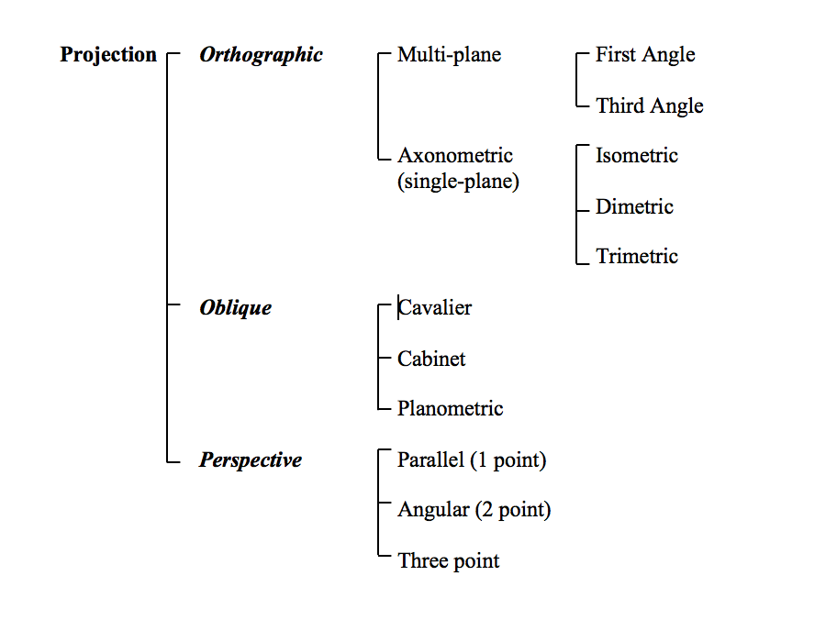 Chart 1 BS 1192 Categories of projection types
In BS 1192 classification, all orthographic and oblique projections are specified as parallel projection systems, since their projectors, those virtual lines of projection that link salient features of the object to points on the plane of projection, or picture plane, are parallel. Perspective projections are classified as convergent systems since their projectors converge on a point through and in front of the plane of projection, assumed to be a viewer’s eye.
The projection types of BS 1192 tabled above are defined in terms of primary geometry, but perhaps do not relate easily to students’ observational experiences. John Willats (1997: 42) usefully re-classified BS 1192 in terms of secondary geometry, Chart 2.
For example, in the original BS 1192, axonometric drawings which show three faces of an object have to be classified with orthographic projections which show only one face, because their primary geometries have parallel projectors in common. Willats suggests it would be beneficial to re-classify the axonometrics under oblique projections, thus recognising their obvious similarities of secondary geometry, which are the number of faces shown in the drawings, and the angled, parallel direction of their orthogonals, the drawn lines representing the edges in the scene that lie perpendicular to the picture plane (Willats 1997: 2)

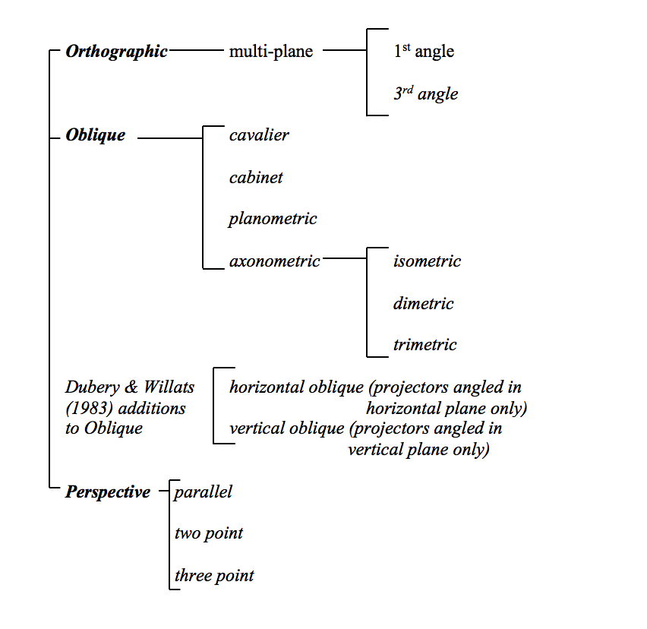

Chart 2 Adapted from John Willats’ re-classification of BS 1192 in terms of secondary geometry

This re-classification of projections in terms of their secondary geometry provides a way of understanding those drawings which do not depend upon the Drawer’s position defined by primary geometry but which, in their secondary geometry, display features of the object that are known, but would not be necessarily visible to the Drawer in a fixed position.
Orthographic projection systems
Multi-plane orthographic projection
This allows several views of an object to be projected upon several planes of
projection assumed to be at right angles to each other: Each object face is parallel with its
plane of projection. Projectors are parallel and are perpendicular to the planes of
projection. Normally, in engineering and architectural drawings, each projected view is
displayed separately. In the case of Figure 1, plan view of the pool is juxtaposed with front and side elevations of fish, ducks and trees:
Figure 1 Multi-plane orthographic projection. Thebes, Egypt c1350BC Nebamun’s Garden Paint on plaster, 64cms high. British Museum. (Public Domain via Wikimedia Commons)

Oblique projection systems
Oblique projections all have one face of the object parallel to the plane of projection, (the sub-set of axonometrics being an exception in Willats’ re-classification) and all projectors, are parallel to each other, but inclined to the plane of projection in various ways.
Oblique projection is evident in drawings from various cultures and periods; Figure 2
shows the front face of the building parallel with the plane of projection (the picture
plane), orthogonals of the main building parallel and sloping downwards to the right,
and those of the raised terrace, (bottom right) sloping upwards to the right!
Figure 2 Oblique projection. Bihzad 1494 Laila and Majnun in School. Illustration from Khamsa (Five Poems) by Nizami. © British Library Board. Or6810 folio106verso.

Planometric projection is a special case of oblique projection, where the plan face of the object is parallel to the plane of projection (and usually rotated through 45º) with parallel projectors inclined obliquely to the plane of projection. (Often inaccurately called ‘axonometric’ which is the generic term for the view of an object tilted so that all three faces are inclined to the plane of projection, with projectors parallel and perpendicular to the plane of projection, and orthogonals angled on the picture-plane.)
Planometric is often used by architects because it allows views of facades as well as into spaces projected from true plan views:
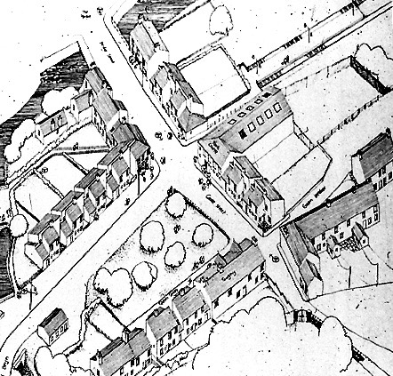
Figure 3 Planometric projection. Howard Riley Glyncorrwg. (detail) Ink on A1 paper.
Axonometric projection
Projectors are parallel and perpendicular to the plane of projection, and all object faces are
inclined to the plane of projection. In Figure 4, the bed is in axonometric (isometric)
projection, the building in oblique. The gateway doors are in oblique confusion!
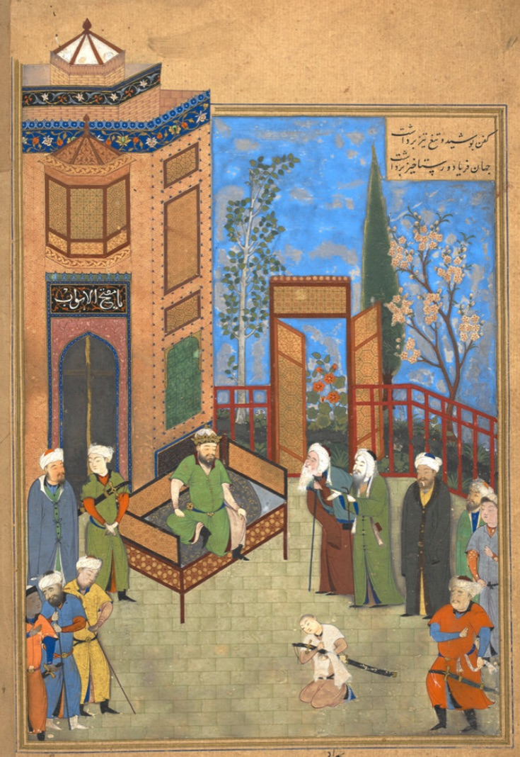
Figure 4 Axonometric (isometric) projection. Bihzad 1494-5 The Elders Pleading before
Hurmuzd on Behalf of the Young Khusraw. Illustration from Khamsa (Five Poems) by
Nizami. © British Library Board. Or6810 folio037verso.

Isometric projection is a unique case of axonometric in which foreshortening on all three
axes is the same. Dimetric has equal scaling along two axes, and in Trimetric projection, all three axes are scaled differently.
Two other forms of oblique projection, not identified in the British Standard (1969:31-34), have been codified by Fred Dubery and John Willats (1983:22,26):
Horizontal oblique projection. One face of the object remains parallel to the plane of projection and projectors are parallel, but are inclined to the plane of projection in the horizontal direction only:
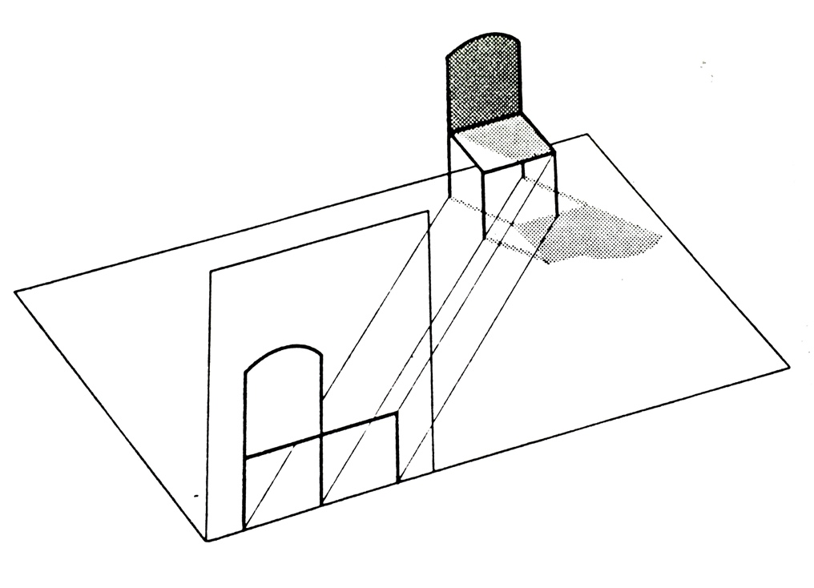
Figure 5 Horizontal oblique projection (Dubery and Willats 1972)
Vertical oblique projection. One face of the object is parallel to the plane of projection, the projectors are parallel but inclined to the plane of projection in the vertical direction only:
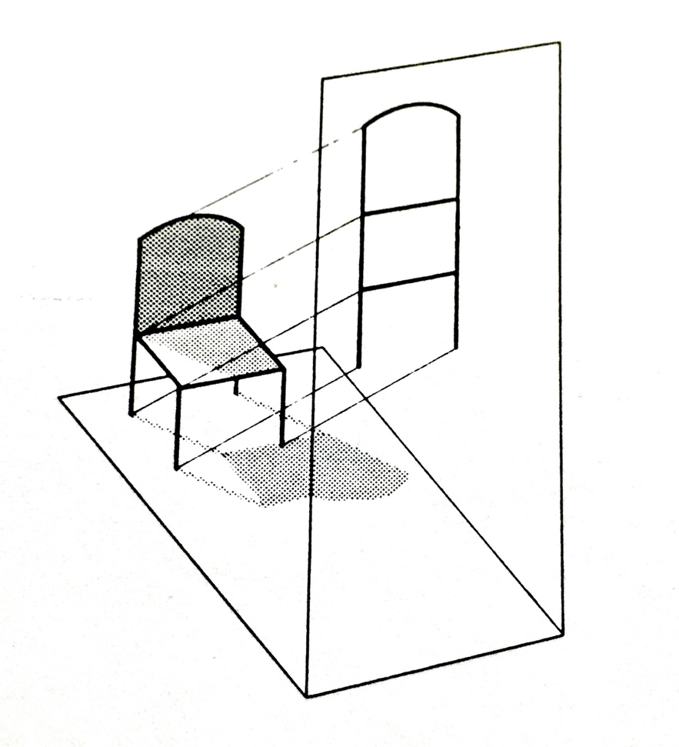

Figure 6 Vertical oblique projection (Dubery and Willats 1972)

The fountain, bottom left in Figure 2, is in vertical oblique projection.

Perspective Projection
This set of projection conventions as defined in primary geometry by BS 1192 (1969:34) differs from orthographic and oblique projections because lines (projectors) from the object through the plane of projection are not parallel, but converge to a point, regarded as the position of an observer’s single, static eye.
1 Parallel (1-point) perspective
The object has all its faces either parallel to, or at right angles to the picture plane.
Orthogonals converge to a single vanishing point:
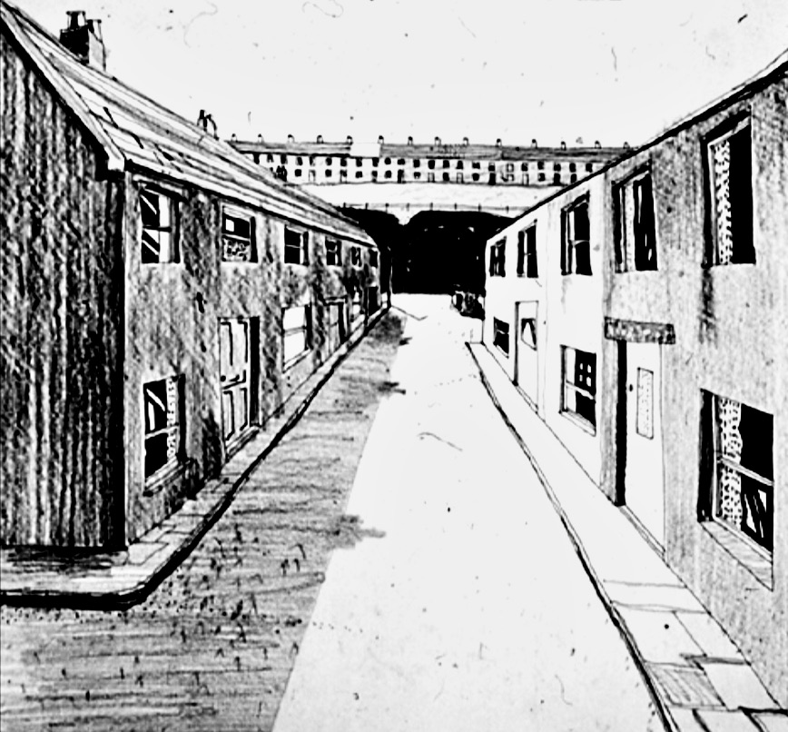
Figure 7 One-point perspective. HR
2 Angular (2-point) perspective
Vertical faces of the object are inclined to picture plane, horizontal faces remain normal
(at 90 degrees) to the picture-plane.
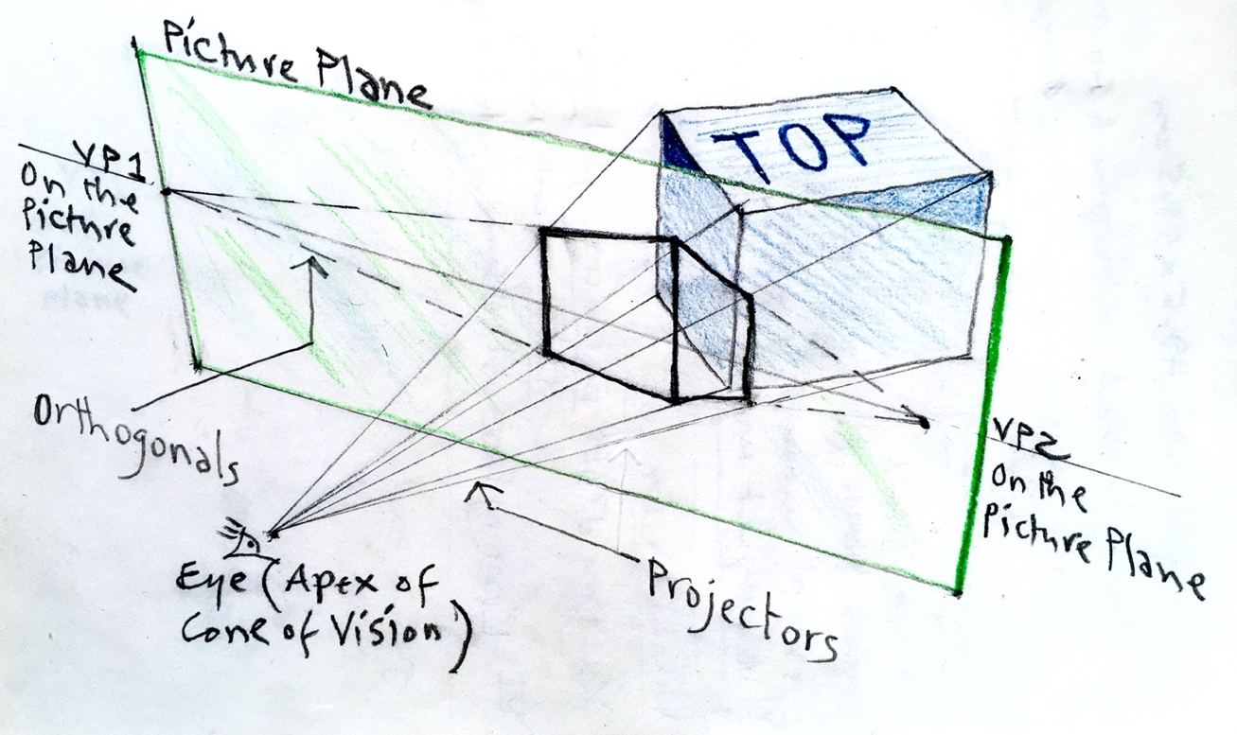
Figure 8 Relationship between Picture Plane, Projectors, Orthogonals and Vanishing Points in 2-point Perspective.

The secondary geometry of the picture is formed at the intersection of all projectors with the picture plane. Parallel edges on the object, inclined to the picture plane, appear in the picture as lines (orthogonals) converging to a point on the picture plane, known as a vanishing point, VP. There are two vanishing points (VP1 and 2) located on the picture plane. Choosing how far apart to place the VPs determines the degree of distortion of the drawing.
3 Three-point perspective
All the object’s faces are inclined to the picture-plane. There are three vanishing points,
the third located above or below the horizon line:

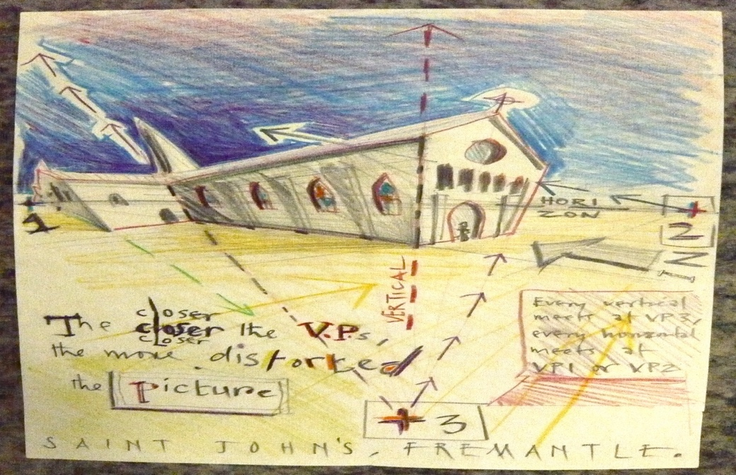

Figure 9 Three-point perspective projection. HR

Projection systems not included in BS:
Divergent Perspective
This term describes drawings in which the orthogonals diverge. Willats points out that this system together with horizontal oblique projection was the most commonly used in Byzantine art and Russian ikon painting during a period of over a thousand years.
Topological Geometry
Drawings which map spatial relations such as connections, separation and enclosure, rather than resemblance and accurate scale make use of topological geometry. Such drawings may be more easily understood in terms of an object-centred secondary geometry. Australian Aborigine art is often constructed using topological geometry, mapping the spatial connections between water-holes and other important locations such as food sources.
‘Fold-out’ Drawings and Multiple-view Drawings
These drawings display information about various aspects of objects and spaces simultaneously. This is not possible in drawings dependent on single-plane projections based on primary geometry.

Each one of the ways of drawing discussed above makes certain information about three-dimensional objects and spaces explicit, but at the expense of other information that is obscured. Therefore the choice of a particular way of drawing will depend upon what specific information about the scene, as well as the viewer’s position relative to the scene, is deemed important enough to be represented in the drawing. Moreover, such decisions will vary according to the intended purpose of the drawing, for whom it is intended, and according to the socially-conditioned ways in which people construe the relationship between themselves and their environment at different ages and in different periods of history. The perceptual psychologist Margaret Hagen (1986) in her review of the variety of geometries deployed in a variety of cultural contexts, indicates the historical, cross-cultural context in which a pedagogy of drawing might be developed.
Perspective in Perspective
Most authorities agree that linear, one-point perspective geometrical projection was invented by Filippo Brunelleschi in Florence. Martin Kemp (1990: 9) cites a source which suggests the date of 1413.
There are two positions that have made the topic of perspective projection a central issue in Western visual culture: Erwin Panofsky (1997: 66) writing in 1927 described perspective as ‘symbolic form’, arguing that it was ‘[…] a translation of psychophysiological space into mathematical space: in other words, an objectification of the subjective’.
In agreement with Panofsky, Nelson Goodman (1976:14) argued that perspective is conventional, in the sense that ‘Pictures in perspective, like any others, have to be read, and the ability to read has to be acquired’. James J. Gibson disagrees:
[…] from what I know of the perceptual process, it does not seem reasonable to assert that the use of perspective in paintings is merely a convention, to be used or discarded by the painter as he (sic) chooses. Nor is it possible that new laws of geometrical perspective will be discovered, to overthrow the old ones. It is true that the varieties of painting at different times in history, and among different peoples, prove the existence of different ways of seeing, in some sense of the term. But there are no differences among people in the basic way of seeing – that is, by means of light, and by way of the rectilinear propagation of light. When the artist transcribes what he sees upon a 2-D surfaces, he uses perspective geometry, of necessity.
(Gibson 1960: 227)

Ernst Hans Gombrich (1960) too, derides the idea that perspective is merely a convention which does not represent the world as it looks. Artificial perspective is a projection system whose primary geometry is based upon what Gibson (1979: 283) termed the natural perspective of an array of light reflected from surfaces and converging on the eye. It assumes the viewing position is monocular, and static. In terms of secondary geometry , all orthogonals converge on a point known as the vanishing point. Its invention was the culmination of a long-standing desire to produce what Kemp (1990: 9) described as ‘the imitation of measurable space on a flat surface’.
Of the two positions, the conventionalist is open to the most criticism. Goodman’s (1976: 15) claim that to learn how ‘[…] to read pictures drawn in reversed or otherwise transformed perspective’ is no harder than it is to read a scene represented in perspective is readily refuted by Michael Kubovy (1986: 122-5). The other position, held by Gombrich and Gibson, whilst it ‘[…] errs on the side of overgeneralisation’ (Kubovy 2014), does draw on pictorial depth cues which trigger specialised perceptual modules in the brain.
Perspective not only constructs a monocular view from a fixed position, but implies that the viewpoint can change in a systematically consistent way to provide further views of the same environment. The integration of subject and object in a coherent space is suggestive of metaphysical completeness. As Crowther (2016: 46) puts it: ‘Space is disclosed as an infinite system of possible viewing positions each correlated exactly with the others’.
The teaching of drawing at higher education level would benefit from a context which introduces a philosophical inquiry into space and our relationships within it:
The constitutive interconnectedness of things makes perspective a component of a relational ontology rather than a mere graphic convention. Crowther (2009: 3) develops a phenomenological argument for the reciprocity of subject and object in the achievement of what he calls ‘phenomenological depth’:

Phenomenological depth […] centres on the ontological reciprocity of subject and object of experience. The embodied subject is immersed in a physical world which is not dependent on that subject for its existence and which, indeed, determines the character of the subject (in terms of both its physical constitution and the activities in which it must engage, in order to survive).
At the same time, however, the nature of the physical world as perceived is itself given a specific character through the range of cognitive and motor capacities which the subject brings to bear upon it. The ontological structure of the subject and its objects of experience are thus reciprocally correlated in key respects. At the experiential level, each is, in effect, part of the full definition of the other.

In contrast with all other geometric projection systems, the geometry of perspective configures points, lines and planes that systematically relate an observer’s viewpoint to the vanishing points at infinity for all objects within the field of view. Its mathematical/conceptual idealisation and abstraction, rather than being alien to a phenomenology of space, is fundamental to it. The geometry is inherent to the phenomenology of space in a way that is consistent with our innate perceptual and cognitive capacities. The geometry of perspective constructs an extensive continuum that forms a ground of extended appearance and embodiment. This extensive continuum is the primordial condition for the appearance of objects, it is a ground of perception rather than an object of perception or a concept.
Pictorial perspective provides compositional structures involved in broad developments concerning Western conceptions of perceptual relations.
The articulation of space constitutes a profoundly motivational aspect of drawing practice, and landscape in particular provides an important medium, rather than simply subject, for its realisation. A ‘negative critique’ (Newell 2012: 49) of the concept of landscape in an art context has implied an objective autonomous world outside ourselves, with strong connotations of romanticism: the land as vista across which we can only gaze… Environment, on the other hand, implies a subjectivity, relating to the substances, surfaces and media (air, water) which surround us, in which we act, with which we interact. So landscape is more usefully construed as the environment as experienced, where the concept can be found in the sensation. It is fundamentally perspectival, it integrates the relationship of subject and object, of mind and matter, we are aware of ourselves here whenever we are aware of an object there. The experiential interplay between subject and object in the context of landscape can be said to issue in the mutual actualisation of self and world. Landscape, as conceived in this way, manifests a relational ontology.
While a drawing proceeds, space is made apparent; scale, depth and character emerge in often surprising ways. Drawing makes space visible within a complexity of relations and potentialities that cannot at first all be seen together; a landscape drawing forms over time, a complex synthesis of perceptual events, it is a process of constructive revelation. Every touch, detail and relation is a materialised thought. The perceiving subject is intimately spatial, oriented and situated. Beyond the physical features of landscape, one of the fundamental concerns and motivations of the drawing process is with revealing, creating and manipulating space; its unity, character and perspectival integration being bound up with the drawer’s situated experience over time. Figure 10 indicates this integration:
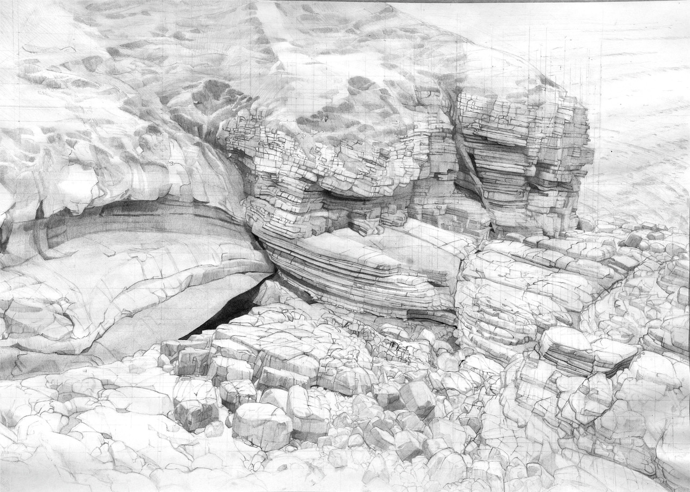
Figure 10 Robert Newell Limestone Cliffs: Caim. Pencil and watercolour on paper 49x68.5cms.
Pedagogical directions
The amalgam of the egological and the ecological proposed in this article lends itself to pedagogical applications (illustrated in Riley 2020a). In general terms, drawing practice could be directed in the following ways:
Egological:
1 Attention to the inevitable relationships between a selected medium and ground: the scale and textural properties of subsequent marks made; choices influencing bodily movements.
2 Attention to the relationship between the student’s gestures, and the subsequent marks with potential to represent the passing of time and hand pressures applied in the process. Also attention to the possibilities of gesture as individual responses to external (or internal?) stimuli: the tradition of expressionist explorations, but with a degree of intentionality.
3 Attention to the range of geometrical projection systems which address the positioning of a viewer in relation to objects in space, and their relations with a viewer’s position; static, multiple or moving.
Ecological:
1 Attention to the ‘channels of perception’: the haptic related to textural qualities of the subject matter under observation; the distal, concerning the arrangement in space of the various surfaces and edges within the scene; and the proximal, related to the overall pattern qualities of the scene, viewed through one eye.
2 Attention to manipulating gradations of tone and texture in mark-making, equivalents representing distance, and the inclination of surfaces relative to the viewer.
3 Attention to cross-cultural systems of projective geometry designed to represent the relationships between objects in space and a viewer’s possibilities of placement.
Summary
Let no-one enter here without an appetite for Geometry
This adaptation of Plato’s apocryphal warning at the entrance to his Academy might carry some hint of the need inherent in many drawing studios. Drawing is one of the most direct visual means of exploring and communicating an understanding of the fundamental facility we have of making sense of the world. The more we understand our processes of visual perception and transformational geometries, the better placed we are for producing new knowledge about our relationships with our environment, in the form of shareable drawn equivalents. To bring together an understanding of the psychology of perception – both egological and ecological - with an awareness of the means of representing perceptual experiences in terms of geometric projection systems, is to enhance the pedagogy of drawing for teachers, and the intelligence of seeing for students.
Imagine a school that didn’t nurture literacy or encourage competence in the visible evidence of its attainment: writing. Unlikely? Imagine a school that regarded numeracy as a means to indulge self-expression with scant attention to the mechanisms of mathematics. Absurd? Now imagine the school that didn’t nurture visualcy as a means of developing an intelligence of seeing, an intelligence appliable to the full range of visual creative arts - and much else, a means of drawing out alternative representations of the relationship between the individual and their physical environment through an understanding of the principles of geometric projection; a means of visually reconstruing the commonplace, and thus a means to new knowledge…
Endnotes
1 Thomas Natsoulas (1990; 1994; 2015) provides a challenging read which relates Husserl and Gibson; Andrea Zhok (2016) contrasts the two in his article On the Reality of Percepts: Husserl and Gibson; Scott C. Richmond (2016) relates Merleau-Ponty and Gibson, in his chapter Ecological Phenomenology.

References
Alsop, W. (2002), Society’s inability to draw is destroying the art of looking, The Architects’ Journal 216:13 (10 October 2002)

Booker, P.J. (1963), A History of Engineering Drawing, London: Chatto & Windus.

British Standard 1192 (1969), Recommendations for Building Drawing Practice, London: British Standards Institution. Revised June 2015 BS ISO 128-43 Available at:
https://doi.org/10.3403/30314911

Crowther, P. (2009), Phenomenology of the Visual Arts (even the frame), Stanford, CA: Stanford University Press.

Crowther, P. (2013), Phenomenologies of Art and Vision: a Post-Analytic Turn, London & New York: Bloomsbury.

Crowther, P. (2016), How Pictures Complete Us: the Beautiful, the Sublime, and the Divine, Stanford CA: Stanford U.P.

Crowther, P. (2017), What Drawing and Painting Really Mean. The Phenomenology of Image and Gesture, London: Routledge.

Drummond, J.J. (1990), Husserlian Intentionality and Non-Foundational Realism: Noema and Object, Dortrecht: Kluwer.

Dubery, F. and Willats, J. (1972), Drawing Systems, London: Studio Vista.

Dubery, F. and Willats, J. (1983), Perspective and Other Drawing Systems, London: The Herbert Press.

Edgar, D. (2019), Agitating the void: drawing and phenomenology, Tracey 14:1 ISSN 1742-3570.

Fava, M. (2011), What is the role of observational drawing in contemporary art & design curricula? In Norman, E. and Seery, N. (eds.) Graphicacy and Modelling. IDATER Online Conference 2010. Loughborough: International Conference on Design & Technology Educational Research & Curriculum Development (IDATER) pp129-141. ISBN 978-1-907382-51-2

Fava, M. (2019), A decline in drawing ability? International Journal of Art & Design Education, 39:2 pp319-332.

Gibson, J.J. (1950), The Perception of the Visual World, Boston MA: Houghton Mifflin.

Gibson, J.J. (1972), A theory of direct perception, Royce, J. and Rozeboom, W. (eds.) The Psychology of Knowing, New York and London: Gordon and Breach. pp215-27.

Gibson, J.J. (1979), The Ecological Approach to Visual Perception, Boston MA: Houghton Mifflin.

Gombrich, E.H. (1960), Art and Illusion. A Study in the Psychology of Pictorial Representation, Oxford: Phaidon.

Goodman, N. (1976), Languages of Art. An Approach to a Theory of Symbols, Indianapolis: Hackett.

Graham, J. (2015), Recording the Stream of Consciousness: A Practice-led Study of Serial Drawing, PhD thesis, Loughborough University. Available at: https://www.academia.edu/19243625/

Hagen, M.A. (1986), Varieties of Realism. Geometries of Representational Art, Cambridge: Cambridge U.P.

Harty, D. (ed.) (2019), Proceedings of the conference ‘Drawing phenomenology: tracing lived experience through drawing’, Tracey 14:1 ISSN 1742-3570

Husserl, E. (1982, 1913), Ideas Pertaining to a Pure Phenomenology and to a Phenomenological Philosophy, First Book, Dortrecht: Kluwer.

Husserl, E. (1960, 1931),Cartesian Meditations. An Introduction to Phenomenology, The Hague: Martinus Nijhoff.

Kemp, M. (1990), The Science of Art: Optical Themes in Western Art from Brunelleschi to Seurat, New Haven CONN: Yale U.P.

Kubovy, M. (1986), The Psychology of Perspective and Renaissance Art, Cambridge: Cambridge U.P.

Kubovy, M. (2014), Psychology of perspective, Kelly, M. (ed.) Encyclopedia of Aesthetics, 2nd ed. Oxford: Oxford U.P.

Marr, D. and Nishihara, H.K. (1978), Representation and recognition of the spatial organization of 3-D shapes, Proceedings of the Royal Society, London, Series B 200. pp269-294.

Merleau-Ponty, M. (1963, 1942), The Structure of Behaviour, London: Methuen.

Merleau-Ponty, M. (1945), Phenomenology of Perception, London: Routledge and Kegan Paul.

Merleau-Ponty, M. (1964, 1961), Eye and Mind, The Primacy of
Perception and Other Essays on Phenomenological Psychology, the Philosophy of Art, History and Politics. (trans. Edie, J. M.) Evanston: Northwestern University Press. pp159-90.

Moran, D. (2005), Edmund Husserl. Founder of Phenomenology, Cambridge: Polity.

Natsoulas, T. (1990), Reflective seeing: an exploration in the company of Edmund Husserl and James J. Gibson, Journal of Phenomenological Psychology, 21:1 pp1-31.

Natsoulas, T. (1994), Gibson’s environment, Husserl’s ‘Lebenswelt’, the world of physics, and the rejection of phenomenal objects, The American Journal of Psychology, 107:3 pp327-358.

Natsoulas, T. (2015), Consciousness and Perceptual Experience: An Ecological and Phenomenological Approach. Cambridge: Cambridge U.P.

Newell, R. (2012), Landscape; drawing and the morphological sublime, Journal of Visual Art Practice, 11:1 pp49-61.

O’Toole, M. (2011), The Language of Displayed Art, London: Routledge.

Panofsky, E. (1997, 1927), Perspective as Symbolic Form, New York: Zone Books.

Peirce, C.S. (1867), On a new list of categories. Peirce Edition Project (eds.) 1982 The Writings of Charles S. Peirce: A Chronological Edition, Vol.2. Bloomington IN: Indiana U.P. pp49-58.

Richmond, S.C. (2016), Cinema’s Bodily Illusions. Flying, Floating and Hallucinating, Minneapolis: Univ. of Minnesota Press.

Riley, H. (2001), Drawing as transformation: from primary geometry to secondary geometry, Proceedings of the 4th Generative Art conference, 2001. Milan: Politecnico di Milano. Available at: http://www.generativeart.com

Riley, H. (2020), The case for the primacy of visualcy within a neo-liberal artschool curriculum, Arts and Humanities in Higher Education, Online 5 Feb. 2020 https://doi.org/10.1177/1474022220903444

Riley, H. (2020a), Ego meets Eco: a strategy for the teaching of drawing, Thinking Through Drawing 2020 Symposium. Available at: https://repository.uwtsd.ac.uk/id/eprint/1466

Saussure, F. de (1916, 1974), Course in General Linguistics, Glasgow: Fontana Collins.

Schenk, P. (2005), Reflections on the teaching of drawing in the digital age: attitudes of senior academics in the UK to the place of drawing tuition on the design curriculum in higher education, Art, Design and Communication in Higher Education, 4:3 pp189-203.

Schenk, P. (2014), Inspiration and ideation: drawing in the digital age, Design Issues, 30:2 pp42-55.

Willats, J. (1997), Art and Representation. New Principles in the Analysis of Pictures, New Jersey: Princeton U.P.

Zhok, A. (2016), On the reality of percepts: Husserl and Gibson, Phenomenology and Mind, 4 pp63-72. https://doi.org/10.13128/Phe_Mi_19587

