Submitted Nov2021. Re-Submission to Art, Design & Communication in HE journal
Accepted 26 Jan 2022

Drawing Matters

Howard Riley
Professor Emeritus, Swansea College of Art, University of Wales Trinity Saint David.

Michelle Darlington
Head of Knowledge Transfer, Cambridge Centre for Social Innovation,
Cambridge University.

Abstract
As the faculties of literacy and numeracy are universally recognised as worthy of pedagogical nurturing, so this article champions an older, graphic articulacy: visualcy. An articulacy with the language of drawing which distinguishes the visual arts from other disciplines. Its nurturing has been compromised by the shift away from teaching drawing in UK secondary schools and HE art schools, even before Covid. We argue that this shift is in part a consequence – perhaps unintended - of the neoliberal values permeating the UK education sector. The article presents a critique of the those values seen as a significant obstacle to drawing’s educational benefits, and offers an optimistic basis for its place in the curriculum.

Keywords
Drawing as language; Visualcy; Neoliberalism; Intelligence of seeing

Preface
This article developed from discussions between the two authors with a common concern about the status of drawing pedagogy across the UK education system. It argues that drawing is fundamental to a visual arts pedagogy at all levels, and for its own sake, since it is the basis for the development of an intelligence of seeing¹ (Riley 2008).
Why drawing is fundamental to an education system
According to the Oxford English Dictionary (OED) the term ‘drawing’ has deep Germanic roots, and has grown into English via Gothic, Old Norse, Old High German, Old Saxon and Old English. Its meanings are many, but condense around the sense of pulling, as in drawing pen across paper, or drawing someone or something out. The word ‘educe’, meaning ‘to draw forth, to bring out, develop from a condition of latent, rudimentary or merely potential existence’ (OED) has its root in the Latin educere¸ to lead out. Hence, ‘educate’, from the Latin educare, related to educere.
It may be argued that the two verbs ‘to lead’ and ‘to draw’ have senses that are synonymous, which allows the fortuitous proposition that drawing is synonymous with education! But there’s more…
Drawing has been a prime means of acquiring and communicating knowledge and understanding from our species’ first appearance on the planet: one of our earliest drives² as human beings was to invent shareable visual equivalents for our perceptual experiences of natural phenomena through the most direct means of engaging with, and communicating results of that inquiry: the language of drawing (Riley 2019). Steven Mithen (1996:159-60) explains our capacity for visual art emerged as the product of a ‘cognitive fluidity’ resulting from the amalgamation of three types of intelligence: a natural history intelligence; a social intelligence; and a technical intelligence, early indications of which may still be seen in caves around the world. Let’s not allow such fluidity to become quiescent, simply because we have the means at our fingertips to capture images without even looking (the digital at our digits!), obviating the opportunity for meaningful engagement, for contemplation of how our visual field (the extent of the arrays of light arriving at our eyes) relates to the visual scene (the layout of material surfaces and edges we see) and our position relative to our environment; together with how that relationship may be shared, communicated through drawn equivalents: selections from the paradigms of line, shape, tone, colour and texture, combined syntactically, producing effects of scale, proportion, contrast, pattern and rhythm. Such visual articulacy, affording the production of alternative constructions, becomes the means to visual creativity: the visual means of sharing new ideas across the whole range of academic disciplines.
The argument for drawing’s place in the curriculum is too persuasive to ignore: it has been recognised for some time that the inclusion of the arts in education can enhance learning in non-arts domains (Winner and Hetland 2000; Winner, Hetland et al. 2019; Simmonds 2021), but this article argues that drawing, specifically, positively promotes learning across the curriculum, as Princeton academic Judith Fan (2015: 170) confirms:
…evidence from the cognitive science and educational research literatures that bears on the question of how drawing, the most basic visualization technique, interacts with cognitive functions that are core to scientific thinking, including: observation, problem-solving, explanation, and communication. Expanding the role of graphical literacy in science education may carry the potential to better reveal to students the dynamic and inquiry-based nature of scientific thinking, especially in contexts where visual representations have traditionally been subordinate to linguistic and numerical representations.

The Contemporary Problem (and where it came from)
It would be encouraging to report even more recent evidence of a rethinking of the secondary schools’ curriculum with specific references to the centrality of drawing. Announcements of two recent reviews raised hopes…firstly, The Durham Commission on Creativity and Education (2019) chaired by Nicholas Serota was one such opportunity, the result of an inquiry set up in September 2017 by Durham University and Arts Council England. But instead it adopts earlier work by Government advisors John Sorrell, Paul Roberts and Darren Henley (2014), and their incongruent triad of ‘…literacy, numeracy and creativity (as) the three central pillars of any strong education offer’ (Durham 2019: 35). Creativity is defined as ‘The capacity to imagine, conceive, express, or make something that was not there before’. No mention of drawing as the most direct means of such expression, or its function as a key stage in the making of anything, as Patrick Maynard (2005: xv) reminds us: ‘A modern world could not exist without drawing, since all the manufactured items of that world, including cameras, must be drawn several times before they can be made, and many could not be used without further drawings’.
Secondly, the Welsh Government’s The Curriculum for Wales was published 28 January 2020 in response to Graham Donaldson’s commissioned report of February 2015, Successful Futures, an independent review of curriculum and assessment arrangements in Wales: six areas of learning are identified, one of these, the ‘expressive arts’, is sub-divided into art, dance, drama, film and digital media, and music. Under Section 5 of the document, sub-titled Designing Your Curriculum, presumably addressed to teachers, a list referring specifically to art appears, leading, a little confusingly, because of undue alphabetical precedence, with ‘architectural design’ and ‘advertising’. The two generic terms ‘craft’ and ‘design’ are then listed under the heading ‘art’; tautologically, since specific material-based traditional craft practices such as ceramics and textiles, and design specialisms of packaging, interiors and communication graphics are included too. However, ‘drawing’ does appear! Eighth (yes - 8th) in this list of recommended areas of learning, even though any sensible teacher would recognise its priority in the visual realisation of ideas in all the other activities. So despite strong research evidence, the potency of visualcy³ – a neologism that Sorrell, Roberts and Henley might have found useful to balance their out-of-kilter triad mentioned earlier - is still to be fully recognised and realised across curricula devised by educationalists labouring under a limited awareness of the educational and cultural centrality of drawing.
The timeline of the historical changes in status of UK art schools within the higher education system from Henry Cole’s time, via the two Coldstream Reports, 1960 and 1970, the emergence of polytechnics and the post-1992 universities, is well documented: Stuart Macdonald’s (1970) seminal study was followed by his Articidal Tendencies (1973) warning of the domination of conceptual art in the curriculum at that time; Katrina Hjelde (2015) and Nicholas Houghton (2019) have both made useful contributions to the tracking of the later developments. Houghton (2016:1) proposed a taxonomy of curricula, seeking ‘…to understand the present-day post-secondary art curriculum through analysing its history in terms of changes in conceptions of art’. Six variations were identified, Fig 1 relates them to the philosophical bases relevant to a drawing pedagogy:

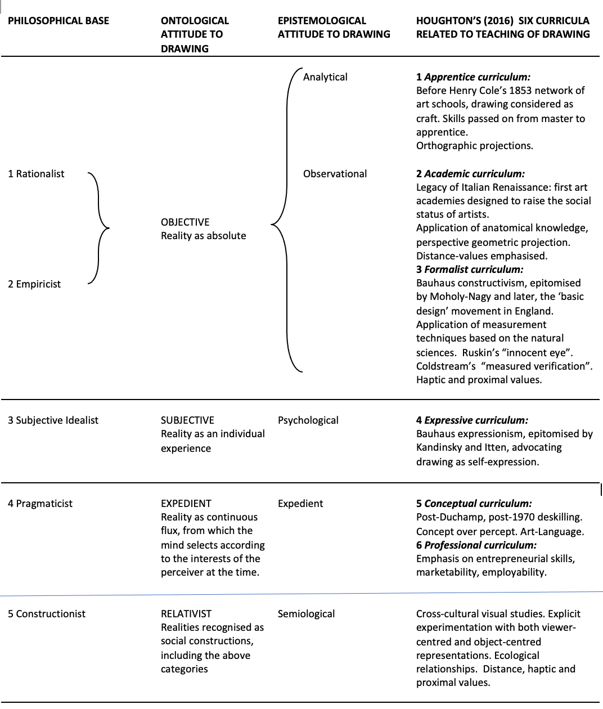
Fig 1 Philosophical bases related to the pedagogy of drawing
It is argued that the demise of drawing in our contemporary education system is directly caused by the neoliberal policies which are affecting the visual arts curriculum from secondary school level through to the HE system. That resulting curriculum version is identified as ‘Professional’ in Houghton’s scheme.
The professional curriculum is tied tightly to a belief that education should be
instrumental and be aligned to enabling students on leaving to earn a living and contribute to a nation’s economy (a jargon word is employability.)
(Houghton 2016:9)

The drivers of those policies misunderstand – or are ignorant of – the advantages of alternative approaches available for the teaching of drawing, and instead assume the narrow notion of observational drawing in the Academic tradition, perceived to be a time-consuming problem in a tight curriculum, is the only choice. However, Figure 1 offers a comprehensive range of approaches: we would advocate a closer consideration of the Constructionist base affording opportunities of benefit to the whole curriculum.
The (mis)perception of drawing simply as a singularly time-consuming activity with an outdated objective of producing proportionally-accurate hand-made observational drawings with no immediate application in a wider cultural environment (construed as an entrepreneurial market setting) is the tacit assumption. Rather, we would argue for, and encourage the articulation of drawing activities as the most economic means of nurturing an intelligence of seeing applicable to all material practices and visual design activities.
Neoliberalism and the art schools
Even though the UK Government-sponsored review led by Philip Augar (May 2019) expressed some doubt about the earlier Browne Report’s (2010:2) assumption that
‘Graduates go on to higher paid jobs and add to the nation’s strength in the global knowledge based economy’ by observing: ‘…increasing the sheer volume of tertiary education does not necessarily translate into social, economic and personal good. That depends on the quality, accessibility and direction of study’ (Augar 2019: 8), we are yet to see a concerted challenge (although Dean Kenning 2018 provides a lead) by the art school sector to the assumption underpinning the Browne report: that high academic qualifications correlate with high salaries. A challenge which should emphasise the social and cultural benefits of an arts education, rather than a crude correlation between graduates and pay-grades. Where did this narrow thinking come from?
‘Neoliberalism‘ is a term generally surveyed by Alfredo Saad-Filho and Deborah Johnston (2005), and exhaustively analysed by Terry Flew (2014). It is associated with notions of a free market in which competition is enhanced through economic deregulation, and the application of social policies designed to favour profit-oriented business.
In the realm of visual art education at the tertiary level, the neoliberal mindset emanating since the 1980s from policies termed New Public Management (Hood 1991; Gruening 2001) is manifested in the policy paper presented to Government by the Competition and Marketing Authority (2015 ) in these general strategies:
The introduction of business logic to university and college management.
Bureaucratic administrative procedures.
Imposing a curriculum dictated by ‘professional practices’ championing strategies of enterprise and entrepreneurialism over an understanding of visual perception and visual communication through material practices.

Research driven by assessment criteria related to economic impact rather than a contribution to original knowledge
Specifically, neoliberal policy has changed the structure and format of art schools within the tertiary sector in ways such as:
Fee paying, adopting the market logic of the private sector.
Amalgamation of art schools into university structures originally designed to teach other academic subjects.
Involvement in the competition between universities, measured by the number of 'firsts' awarded, employability statistics, the Teaching Excellence Framework (TEF), and the Research Excellence Framework (REF) public profile.
Art schools and polytechnics were previously seen as less 'academic' than the universities, which had higher academic entry standards. When they were amalgamated, the university became the default model. (Isomorphism theory = institutions mimic more 'successful' ones, leading to homogenisation of institutions)
The neoliberal format and structure applied to art schools within the university structure prioritises a type of learning with a narrower focus. Courses are now:
Modular fragmented. Quick results are favoured. Experimentation is compromised.
Outcome focused, privileging a learning philosophy focused on outcomes in the cognitive domain, as opposed to: psychomotor skills acquisition; the nurturing of ways of looking and seeing; addressing the affective domain through meditative perception, and attending to emotional responses.
If we are to sustain an art school sensibility, differentiated from the university through discrete activities, we must acknowledge that drawing practices are a key factor in defining the differences, and recognise that current trends in the assessment process might require reconsideration:
Drawing skill acquisition takes many hours of practice which is not conducive to modularity.
Drawing encompasses all three domains of learning: cognitive, affective, and psychomotor.
Technical ability is losing status.
Affective engagement is hard to assess when not accompanied by technical skill.
The lack of appropriate assessment tools for assessing cognitive learning expressed as visual outcome.
(Fava 2011)
The negative outcome of the trend of neoliberalisation of the art schools is summed up by
Andrew McGettigan (2015: 2):
The focus of (neoliberal) policy has been the transformation of higher education into the private good of training and the positional good of opportunity, where the returns on both are higher earnings. Initiation into the production and dissemination of public knowledge? It does not appear to be a concern of current policy.

The impositions upon the art school curriculum influenced by neoliberal policies have resulted in students’ aspirations being diverted from intellectual inquiry towards competitive enterprise, to the point where they are encouraged to assume as natural an entrepreneurial attitude, rather than a role of inquirer into the relationships between perceptual experiences and their visual communication. Modules labelled professional practice have come to be considered as paramount in the education of visual artists. In contemporary usage, the term refers to the acquisition and application of skills and attitudes deemed useful in negotiating a competitive market economy, for example, business acumen and strategies for self-promotion. These, it is argued, are necessary for successful visual arts practice in what is commonly referred to as the ‘real world’, a term which describes one particular construction of reality in which visual inquiry is usurped by commodity aesthetics.
This situation at the tertiary level, where proficiency in drawing is reported as noticeably reduced (Fava 2019), is endemic in the secondary schools, specifically the effects of neoliberal policies adopted by the agencies responsible for quality assessment of the ‘A’ level subject ‘Art’. Recent articles by Michelle Fava (2011, 2019) and Chris Owen (2019) trace the demise of drawing in schools in part to accreditation agencies’ criteria which don’t specify any assessment of drawing per se, but instead tacitly condone digitally-based imaging technologies to provide evidence of ‘visual research’ in the students’ activities. The built-in algorithms of such technologies automatise a crucial transformation, by-passing a function of an intelligence of seeing; the process of finding graphic equivalents for perceptual experiences, for which drawing is best suited. The pressure on teachers to deliver consistent high grades in limited time diminishes any incentive for them to nurture an intelligence of seeing in their students.

In a recent article, Deanna Petherbridge (2019), Professor of Drawing at the Royal College of Art 1995-2001, relates an anecdote from that period about a ‘…careless madness’ to do with attitudes towards the teaching of drawing:
That madness stems from a profound late twentieth-century belief, still prevalent today, that drawing is an entirely individual practice shaped by individual ownership but so free floating that it requires no reference to any larger discourse. That is, drawing can be anything that any artist, art teacher, or museum educator cares to make of it…
(Petherbridge 2019: 2)

A ‘madness’ still prevalent today, indeed! So, what of the present period?
A ‘post-Postmodernist’ time, one that has been identified as ‘Alter-modernism’⁴ in which the art schools’ administrative responsibilities (marketing, recruitment, retention rates, even the monitoring of foreign students’ movements) are offloaded to academics, who rightly regard their prime responsibilities to be the development, enhancement and delivery of visually-based curricula informed by research activities (Martin 2016: 2). The assumption of an art school education being aligned primarily with students’ individual prospects of higher-paid employment, rather than a potential source of knowledge leading to a common social good, is a consequence of the neoliberal policies mentioned earlier. By 2010 a ‘…vision for a more entrepreneurial higher education sector’ (McGettigan 2013: 20) had resulted in legislation permitting HEIs to triple fees as the Government withdrew direct funding. Such a withdrawal of support, an austerity deemed necessary following the global financial crash of 2008, raises a general concern about Government’s ability to recognise the role of the art schools as a source of knowledge for the common good.
Consequences (perhaps unintended, if we are generous in our criticism!) of these managerial trends influenced by neoliberal policy were noted early by Petherbridge who, in her seminal book The Primacy of Drawing, warned:
More recently, under the democratic, pluralistic but also hegemonic imperatives
of universities…individual practice in art departments has become increasingly fragmented through modular teaching and self-directed learning, with students looking outward to the art market and its officiates.
(Petherbridge 2010: 232)

The relevance to drawing is very real. When comparing the value systems it becomes obvious why the product has become valued over the process. In the older models of public sector management, values such as correct procedure and planning took precedence. The new public management is about competition and efficiency: the product is the important thing, not the process. This is disastrous for any practice in which the duration of time is an integral qualitative part: practices such as learning relationships, most services, and of course, drawing (as a process). Now, the prevailing logic is, if you can arrive at the same product more quickly, you should!
A Basis for a Curriculum for Drawing
Observational drawing is being compromised more than other kinds of drawing, and we consider it is still a good idea to teach this, not only because it improves drawing, but because it engages the drawer directly with the things themselves. Looking, without language filtering perception, is an undervalued skill, and the most economic means of nurturing a versatility of perception. More than simply seeing, drawing is about ways of looking, a means of ‘changing channels’.
A clear curriculum for the teaching of drawing is advocated, identified as a ‘Constructionist’ one in Figure 1, based upon two fundamental theoretical bases: those of visual perception and visual communication.
These theoretical bases can inform strategies for the teaching of drawing at all levels of the education system; strategies which can nurture students’ abilities to transform their experiences of the world – perceptual, emotional, imaginational - into articulate and coherent visible forms communicable to others.
Specifically, the pedagogical strategies might be centred upon principles derived from an ecological theory of visual perception first proposed by the visual psychologist James J. Gibson (1979), and aspects of visual communication theory developed by the semiotician Michael O’Toole (2011). Both theoretical bases, rarely cited in the literature on drawing, yet fundamentally relevant to the pedagogy of drawing, are adumbrated here:
Gibson: Organic Perceptual Systems and Levels of Perception

An ecological approach to the explanation of visual perception argues that we have evolved perceptual systems which resonate with the fields of energy such as light so that we are able to respond and react directly to the environmental information contained in the arrays of light arriving at our eyes.
Such information relates to a variety of affordances – possibilities for action - in response to haptic, distal and proximal cues contained in the structure of light. It is this insight of Gibson which allows us to identify the various levels of perception available for our attention; simply put, alternative ways of seeing. The honing of attention to these possibilities of perceptual information through the concentrated practice of observational drawing will, of course, also empower students in their everyday perceptual experiences away from the drawing studio.
O’Toole: The Poetic Function of Communication
Within the classroom and studio, the task is to bring together knowledge gleaned from visual perception theory, and the re-vitalisation of relevant aspects of communication theory. Particularly relevant is the work of O’Toole (2011), and his adaptation of Michael A.K. Halliday’s (1978) systemic-functional model of language via Roman Jakobson’s (1958) prime function of all creative production: the poetic function, which draws attention to the form of the work in question through the deployment of visual rhetorical tropes such as metaphor, metonym and oxymoron, as well as the poetic strategies of composition such as the manipulation of scale, proportion, contrast, visual rhyming, rhythm, pattern, symmetry/asymmetry.
Levels of Perception: a basis for pedagogy at all levels
Visual information about the state of the environment and our positioning within it, information crucial to a visual art, is contained within the structure of light arrays arriving at the eyes (Gibson 1979) and may be classified in three distinct ways. These may be explored in studio or elsewhere through exercises designed to focus attention on the ‘haptic level’, at which information about surface qualities indicating texture and colour may be accessed; the ‘distal level’, to do with information about distance, size, scale and depth of field relative to the viewer; and the ‘proximal level’, which provides information about the overall pattern and rhythm relationships in the visual field as a whole. An example of each level of perception is illustrated in Figures 2-4:
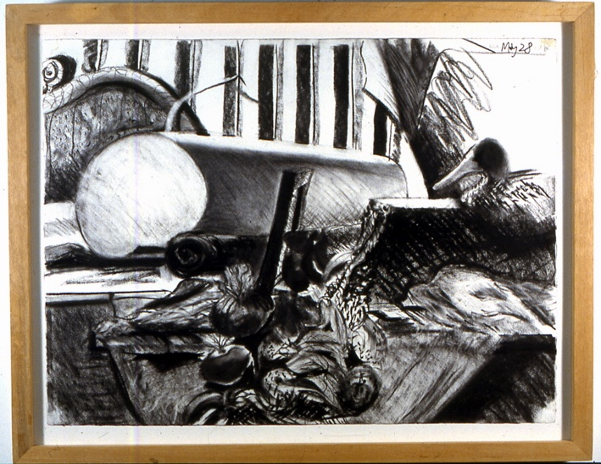
Figure 2 Howard Riley Haptic values: the textural values emphasised
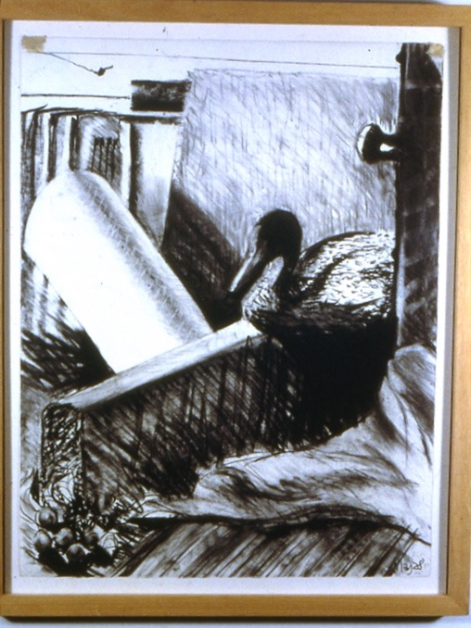
Figure 3 Howard Riley Distal values: Contrast boundaries representing spatial depth emphasised
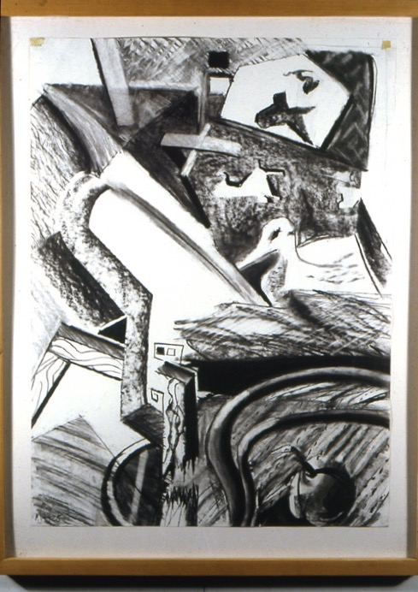
Figure 4 Howard Riley Proximal values: the pattern qualities emphasised
Honing the intelligence of seeing required to manipulate these levels of information is crucial if students are to control the balance between perceptual intrigue and conceptual intrigue (an indication of quality) in their work. Drawing is the most direct and economic means of contemplating these channels of perception. It is therefore best positioned to be the means of release from our language-filtered complacency of vision; it is a primary means of making the familiar strange.
Last words
Learning to draw, while no longer a privileged activity in either school or specialist art teaching, remains an activity of enormous importance and potency for education as a whole. Learning to observe, to investigate, to analyse, to compare, to critique, to select, to imagine, to play and to invent constitutes the veritable paradigm of functioning effectively in the world.
(Petherbridge 2010: 233)

The Office for Standards in Education (OFSTED 2011) raised the alarm:
It is important that teachers of the subject continue to support the development of pupils’ key skills, including literacy and numeracy in primary and secondary schools. However, for all involved in art, craft and design education, drawing is a key skill. Teaching all pupils to draw with confidence and creativity was too low a priority in too many schools. If art, craft and design education is to play a full part in helping pupils ‘make a mark’ in the future, drawing can no longer remain a concern without a cause.

At the suggestion of one of the reviewers, some comment on the Covid situation is offered here. Although the traditional studio context of teaching drawing might be subject to restrictions at the time of writing, the fundamental premise of observational drawing, the transformation of a 3-D scene into a 2-D representation, an exercise which nurtures an intelligence of seeing appliable to the full range of art and design disciplines, may still be explored by students and encouraged, guided by tutors. So long as students have access to basic drawing materials, and online communication platforms for tutorial contact, the probing of the perceptual process may continue wherever the student and tutor feel appropriate, and comfortable.
Finally, some observations of one of the authors, Darlington, on her personal experiences:
One interesting development which works remarkably well is the use of webcams with a live feed of instructors’ and participants’ drawings. An unexpected benefit from leaving microphones unmuted while drawing together allows the sound of charcoal and pencils on paper to be shared, enhancing the sensory ‘studio’ atmosphere for drawers.
Collaborative digital drawing tools like the Zoom whiteboard and others can be fun; trialled during a recent Thinking Through Drawing event, it was found to engender a collaborative atmosphere conducive to work. However, one intriguing aspect of the Thinking through Drawing network virtual events is that the attendance was almost entirely women (we're not really sure why! Suggestions welcome…)
It has been liberating to operate in a virtual space not mediated (controlled) by institutional restrictions which can often involve negotiation with estate administrators. (I hadn't really thought about this aspect before, so it's interesting to reflect on it.)
All in all, drawing online with others has been a much more positive experience than I would have predicted. Whilst we all agree that we’re desperate to draw together in person again, we also wish to continue with the online workshops occasionally, because it is a good way to connect with those situated in remote areas who would otherwise miss the opportunities to participate and contribute.
So whilst the pandemic prevails, let’s for once utilise the digital environment’s powerful portals to their full educational potential: Teams, Zoom, Instagram communications are commonplace these days, and there is additional evidence, taken from an anonymous paper one of the authors, Riley, recently reviewed for the International Journal of Art & Design Education, that “…digital networks (Instagram used for crits) enabled valuable and accessible learning opportunities…” It’s the drawing that matters!
Endnotes

1 In the simplest terms, an intelligence of seeing may be understood as an awareness of the inter-relationships between ways of seeing, social belief systems and ways of drawing. It is appliable to the full range of visual art activities, and essential for the design disciplines.
Adapting Robert Witkin’s (1974) terminology defining an intelligence of feeling, it is the self’s organised process of subject-reflexive action, as opposed to subject-reaction, or ‘knee-jerk’ behaviour. Subject-reflexive action is characterised by a reciprocity between visual stimulus and response, informed by a sense of anticipation and understanding of future consequences of planned action, as opposed to subject-reactive behaviour exemplified by the eye-blink in response to a puff of air (Witkin 1974:14). In the context of visual art pedagogy, intelligence of seeing may be thought of as a cultural superstructure developed from two of the natural, basic human activities crucial to survival since at least Palaeolithic times; firstly, the perceiving of our environment and our individual positions within it, and secondly, the social drive to share – communicate – those perceptual experiences, exemplified by the early cave drawings. A first indicator of an intelligence of seeing would be evidence of a versatility of vision which transcends John Halverson’s (1992: 389) ‘fundamental features of visual perception… figure-ground distinction, Gestalt principles of closure and good continuation’. A versatility informed by an awareness of how to change channels, as it were, so as to extract different levels of information – haptic, distal and proximal - from the scene observed. A second indicator would be evidence of an ability to communicate a range of drawn equivalences for the variety of perceptual experiences, relevant to the aims of the drawing, functioning to convey the response of the drawer as well as positioning viewers in terms of their mood and attitude towards the subject-matter represented in the work.

2 A drive with a long history! In South Africa, a cross-hatched pattern drawn with ochre crayon on a silcrete flake is dated 73,000 years old (Henshilwood, d’Errico et al. 2018). Watch this space! We were certainly drawing long before we were writing; Denise Schmandt-Besserat (n.d: 6) suggests a date of c.5,000 BP in Mesopotamia for the first writing – codified marks upon a surface - to represent speech. In fact, our facility for depiction gave birth to the very notion of written language. Visualcy preceded – facilitated – literacy.

3 Riley (2002:150) first proposed visualcy as an equivalent to literacy and numeracy some time ago. Since then, the case for the neologism has been strengthened by W.J.T. Mitchell’s (2008:11) advocacy. It relates specifically to the facility for analysing the haptic, the distal and the proximal levels of information contained in the structure of the arrays of light arriving at the eyes, and the translation of such information into drawn visual equivalents. The term graphicacy is widely used in cross-curricula contexts, (Danos and Norman 2011) and is here acknowledged as a useful term describing a facility for the design of graphic means such as graphs, charts, maps and diagrams used in the organisation and communication of non-visual data gathered from activities not dependent upon direct visual perception of the environment. Its provenance is found in Balchin and Coleman (1966).

4 ‘Altermodernism’ is a term coined by curator Nicolas Bourriaud in 2009 on the occasion of the Tate Triennial to showcase art made as a comment on standardisation and commercialism, in the context of neoliberalism and globalisation.

References
Augar, Philip (2019), Independent Panel Report to the Review of Post-18 Education and Funding. Available at: www.gov.uk/government/publications Accessed 13 May 2021

Balchin, W.G.V. and Coleman, Alice W. (1966), ‘Graphicacy should be the fourth ace in the pack.’ Cartographica: The International Journal for Geographic Information and Geovisualisation. 3:1 pp23-8.

Browne, John (2010), Securing a Sustainable Future for Higher Education. An Independent Review of Higher Funding & Student Finance. Available at: www.independent.gov.uk/browne-report Accessed 13 May 2021.

Competition and Marketing Authority (2015), An Effective Regulatory Framework for Higher Education. London: UK Govt.

Danos, Xenia and Norman, Edward W.L. (2011), ‘The development of a new taxonomy for graphicacy.’ In Norman, E.W.L. and Seery, N. (eds.) IDATER Online Conference: Graphicacy and Modelling 2010. Loughborough: Design Education Research Group, Loughborough Design School. pp69-84.

Durham Commission (2019), Durham Commission on Creativity and Education. London: Arts Council England.

Fan, Judith E. (2015), ‘Drawing to learn: how producing graphical representations enhances scientific thinking. ‘Translational Issues in Psychological Sciences 1:2 pp170-181.

Fava, Michelle (2011), ‘What is the role of observational drawing in contemporary art & design curricula?’ In Norman, E.W.L. and Seery, N. (eds.) IDATER Online Conference: Graphicacy and Modelling 2010. Loughborough: Design Education Research Group, Loughborough Design School. pp129-141.

Fava, Michelle (2019), ‘A decline in drawing ability.’ International Journal of Art & Design Education. Vol.39 No.2 pp319-332.

Flew, Terry (2014), ‘Six theories of Neoliberalism.’ Thesis Eleven 122:1 pp49-71.
Gibson, James J. (1979), The Ecological Approach to Visual Perception, Boston MA: Houghton Mifflin.

Gruening, G. (2001), ‘Origin and theoretical basis of New Public Management.’ International Public Management Journal 4 pp1-25.

Halliday, Michael A.K. (1978), Language as Social Semiotic. London: Edward Arnold.

Halliday, Michael A.K. (2005), ‘On matter and meaning: the two realms of human experience.’ Linguistics and the Human Sciences 1:1 pp59-82.

Halliday, Michael A.K. (2019), ‘The influence of Marxism.’ In Webster, J.J. (ed.) The Bloomsbury Companion to M.A.K. Halliday. London: Bloomsbury. pp94-100.

Halverson, John (1992), ‘The first pictures: perceptual foundations of Paleolithic art.’ Perception 21:3 pp389-404.

Henshilwood, C.S., F. d’Errico, K.L. van Niekerk, L. Dayet, A. Queffelec and L. Pollarolo (2018), ‘An Abstract Drawing from the 73,000-year-old Levels at Blombos Cave, South Africa.’ Nature 562. 115-118.

Hjelde, Katrine (2015), ‘Paradox and potential: fine art employability and enterprise perspectives.’ Art, Design & Communication in Higher Education 14:2 pp175-188.

Hood, C. (1991), ‘A public management for all seasons?’ Public Administration 69 Spring 1991 pp3-19.

Houghton, Nicholas (2016), ‘Six into one: the contradictory art school curriculum and how it
came about.’ The International Journal of Art & Design Education. 35:1 pp107-120.

Houghton, Nicholas (2019), ‘A 60 year dysfunctional relationship: how and why curriculum
and assessment in fine art in England have always been problematic and still are.’ Art, Design
and Communication in Higher Education. 18:2 pp171-185.

Jakobson, Roman (1958), ‘Closing statement at the conference on Style in Language: Linguistics and Poetics.’ In Sebeok, T.A. (ed.) (1960), Style in Language. Cambridge, MA: MIT Press. pp350-377.

Kenning, Dean (2019), ‘Art world strategies: Neoliberalism and the politics of professional practice in fine art education.’ Journal of Visual Art Practice 18:2 pp115-131.

Macdonald, Stuart (1970), The History and Philosophy of Art Education. London: University of London Press.

Macdonald, Stuart (1973), ‘Articidal tendencies.’ In Piper, David Warren (ed.) Readings in Art and Design Education. Vol.2. London: Davis-Poynter. pp89-99.

Martin, Ben (2016), ‘What’s happening to our universities?’ Science Policy Research Papers. Working Paper Series, 2016-03. Available at: www.sussex.ac.uk/spru/research/swps

Maynard, Patrick (2005), Drawing Distinctions. The Varieties of Graphic Expression. Ithaca: Cornell U.P.

McGettigan, Andrew (2013), The Great University Gamble. Money, Markets and the Future of Higher Education. London: Pluto Press.

McGettigan, Andrew (2015), ‘The treasury view of HE: variable human capital investment.’ Political Economy Research Centre (PERC) Paper No. 6. London: Goldsmiths, University of London.

Mitchell, William J.T. (2008), ‘Visual literacy or literary visualcy?’ In Elkins, J. (ed.) Visual Literacy. London: Routledge. pp11-29.

Mithen, Steven (1996), The Prehistory of the Mind. A Search for the Origins of Art, Religion and Science. London: Routledge.

Ofsted (2011), Making a Mark: Art, Craft & Design Education. Available at:
https://assets.publishing.service.gov.uk/government/uploads/system/uploads/attachment_data/file/413334/Making_a_mark_-_art_craft_and_design_education_2008-11_-_high_resolution.pdf (Accessed 13 May 2021).

O’Toole, Michael (2005), ‘Pushing out the boundaries: designing a systemic-functional model for non-European visual arts.’ Linguistics and the Human Sciences. 1:1 pp83-97.

O’Toole, Michael (2011), The Language of Displayed Art. 2nd ed. London: Routledge.
O’Toole, Michael (2019), ‘Halliday’s three functions and their interaction in the interpretation of painting and music.’ In Webster, J.J. (ed.) The Bloomsbury Companion to M.A.K. Halliday. London: Bloomsbury. pp396-385.

Owen, Chris (2019), ‘Through a glass darkly: the teaching and assessment of drawing skills in the UK post-16 art & design curriculum.’ The International Journal of Art & Design Education (In press)

Petherbridge, Deanna (2010), The Primacy of Drawing. Histories and Theories of Practice, New Haven and London: Yale University Press.

Petherbridge, Deanna (2019), ‘The drawing experiment at the Royal College of Art 1995-2001.’ In Hickman, R. (ed.) The International Encyclopedia of Art and Design Education. London: John Wiley & Sons.

Riley, Howard (2001), The Intelligence of Seeing. An Inquiry into the Relationships between Perception Theory, Communication Theory and the Practice and Teaching of Drawing. PhD Thesis, University of Wales. At: https://www.researchgate.net/profile/Howard_Riley

Riley, Howard (2002), ‘Firing practice: drawing as empowerment.’ Journal of Visual Art Practice 1:3 pp150-161.

Riley, Howard (2008), ‘Drawing: towards an intelligence of seeing.’ In Garner, S. Writing On Drawing. Essays on Drawing Practice and Research. Bristol/Chicago: Intellect Books. pp153-167.

Riley, Howard (2013), ‘Visual art and social structure: the social semiotics of relational art.’ Visual Communication 12:2 pp207-216.

Riley, Howard (2018), ‘Bridging the gap: connecting conceptual and perceptual intrigue within drawing practice.’ Tracey 13 pp1-12. Available at: https://ojs.lboro.ac.uk/TRACEY/article/view/2539. Date accessed: 13 May 2021

Riley, Howard (2019), ‘Drawing as language: the systemic-functional semiotic argument.’ Journal of Visual Art Practice. 18:2 pp132-144.

Saad-Filho, Alfredo and Johnston, Deborah (eds.) (2005), Neoliberalism: A Critical Reader. London: Pluto Press.

Schmand-Besserat, D. (2014), The Evolution of Writing. Available at:
https://sites.utexas.edu/dsb/tokens/the-evolution-of-writing/ Accessed 13 May 2021.

Simmonds, Seymour (2021), The Value of Drawing Instruction in the Visual Arts and Across
Curricula. London: Routledge

Sorrell, John; Roberts, Paul and Henley, Darren (2014), The Virtuous Circle: Why Creativity
And Cultural Education Count. London: Elliot and Thompson.

Winner, Ellen and Hetland, Lois (2000), ‘The arts in education: evaluating the evidence for a
causal link.’ The Journal of Aesthetic Education. 34:3/4 pp3-10.

Winner, Ellen; Hetland, Lois; Veenema, Shirley; Sheridan, Kimberly and Palmer, Patricia
(2019), (1st publ. 2006) ‘Studio thinking: how visual arts teaching can promote disciplined
habits of mind.’ In Locher, Paul; Martindale, Colin and Dorfman, Leonid (eds.) New
Directions in Aesthetics, Creativity and the Arts. New York: Routledge. pp189-208.

Witkin, Robert W. (1974), The Intelligence of Feeling. London: Heinemann.

Witkin, Robert W. (1995), Art and Social Structure. Cambridge: Polity Press.

