Analysing Pictures: A Systemic-Functional Semiotic Model for Drawing
Howard Riley PhD MA(RCA)
Professor of Visual Communication, Dynevor Centre for Arts, Swansea Metropolitan University, Wales, UK.
howard.riley@smu.ac.uk
Abstract
This article is a revised and extended version of a presentation to the conference on Analysing Multimodal Discourse: Systemic-Functional Linguistics meets Pragmatics, held at Loughborough University, September 2011. It discusses the application of systemic-functional semiotics in the analysis of visual materials, and, specifically, presents a systemic-functional model that is intended to facilitate both the analysis and synthesis of drawings in an art school pedagogical context. The model is explained as developing from Michael O'Toole's (1994, 2nd ed. 2011) adaptation of Michael Halliday's (1973;1978;1985) systemic-functional semiotic model for language, and the article is illustrated with examples of the author's drawing practice, and other works.
Keywords
Systemic-functional semiotics; Drawing.
Introduction
In a multimodally conceived communicational world, two
questions arise: one is about the ‘aptness’ of the means for
representation; the other is about the complexes of modes
designed for achieving complex representational and
communicational requirements and tasks. (Kress, 2010)
This paper explores the complexities of the mode of drawing. Extrapolating from Michael Halliday’s insights about the way language operates in a social situation, it becomes feasible, and has proven useful, (Riley, 2001; Riley and O’Donohoe, 2009; O’Donohoe and Riley 2009; Hughes and Riley, 2009; Roberts and Riley, 2011) to propose that any visual means of communication has three functional components, what Halliday (1978:113) referred to as metafunctions : firstly, to convey some aspect of our experiences of the world; secondly, to express our attitude or mood regarding our experience, and also to position the receiver/viewer in terms of their mood and attitude towards that experience shared; thirdly, to structure the previous two into a coherent, perceptible form. The first two metafunctions Halliday labelled the Ideational and the Interpersonal. The third he termed the Textual function. For the purposes of this article, these three will be identified as the Experiential, the Interpersonal and the Compositional, terms more suited to discussion of visual codes of communication such as drawing.
Elaborating Bronislaw Malinowski’s (1923) concept of the context of situation - the social context within which all communication necessarily takes place - Halliday identified the parameters of such a context as field (what is happening), tenor (who is taking part) and mode (what part the semiotic code plays) and systematically related them to the metafunctions of the communication. It is proposed that those meanings which constitute our understanding of any particular social situation can be made visible through the selection and combination of signs available within a code of visual communication such as drawing.

Parameter of social context | Function of drawing through which a social situation is realised
Field (what is happening) | Experiential function
Tenor (who is taking part) | Interpersonal function
Mode (what part the semiotic code plays) | Compositional function

Michael O’Toole, Emeritus Professor of Human Communication at Murdoch University in Perth, Western Australia, was the first to demonstrate the power of Halliday’s insights when they are applied to the analysis of visual work. He offered a semiotic model for the analysis of painting (O’Toole, 1990). Subsequently, O’Toole (2011) has demonstrated the versatility of Halliday’s model by adapting it to theorise how sculpture and architecture may be understood in relation to their social contexts. Gunther Kress and Theo van Leeuwen have also used Halliday’s insights to illuminate the study of graphic design and other forms of visual communication (Kress and van Leeuwen, 1996, 2nd ed. 2006). They have argued that visual means of communication may be construed as rational expressions of cultural meanings, amenable to rational accounts and analysis. The problem, as they perceived it some fifteen years ago and reiterated in 2006, was that literate cultures had “systematically suppressed means of analysis of the visual forms of representation, so that there is not, at the moment, an established theoretical framework within which visual forms of representation can be discussed”. (Kress and van Leeuwin, 1996:20-21; 2006:23). Following these pioneers of a semiotics of the visual, this article proposes just such a theoretical framework within which visual forms of representation, specifically drawing, may be discussed.
A Systemic-Functional Semiotic Model for Drawing
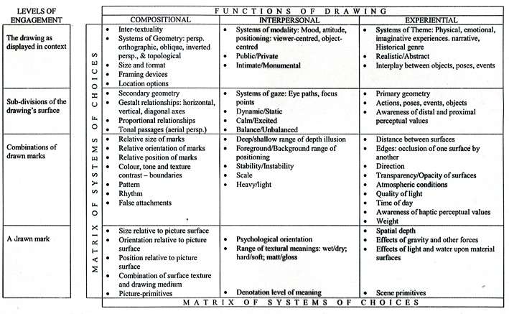
Table 1 A Systemic-Functional Semiotic Model for Drawing
Such a model is presented in Table 1 where the Experiential function relates to a drawing’s ability to represent some aspect of our experience of the world. The Interpersonal function (O’Toole labels this as the Modal) deals with how drawings may express the maker’s attitude to their experiences, and may position the viewer in terms of their attitude and mood. The Compositional function deals with the ranges of available devices through which these other two functions are realised, as O’Toole (2011:11) explains:
an artist has at his or her disposal various devices for
engaging our attention, drawing us into the world of the
painting, and colouring our view of the world…In the
grammar of painting – that is, all those aspects of structure
that we all share – these devices fulfil a Modal function –
and however much our ultimate interpretations might differ,
I want to claim that the responses evoked in us by the systems
of this function are virtually universal.

The term system used by O’Toole here , and earlier by Halliday, is derived from J.R. Firth’s (1957) coinage which describes an available set of choices in a specific context. Systems of choices are available in the production of drawings, from the range of individual marks made by the range of available media upon various surfaces, through the variety of systems of geometry at the drawer’s disposal, up to the range of choices to do with framing, lighting, and ultimately the positioning of the whole work within an environmental context. It is these selections from the systems of compositional choices that combine to make visible, to realise, the other two functions. Hence the term systemic-functional semiotics, introduced by Halliday.
The heading Levels of Engagement in Table 1 refers to the hierarchical layering within which engagement with a drawing is possible. The Matrix of Systems of Choices emphasises the systemic nature of the model: these ranges of available choices do not simply allow meanings to be negotiated within any single function at a specific level of engagement, but they afford the negotiation of meanings through all functions at all levels. In everyday encounters with visual work, these functions are operating simultaneously, of course. Social meanings to do with the drawer’s and viewer’s experience within the field of the real world, and also the tenor of the relationship between drawer and viewer are all realised simultaneously through the systems of Theme, Modality, Geometry and others identified in Table 1. Choices from these systems are realised as particular modes of drawing which are themselves realised as appropriate combinations of drawn marks upon a surface.
Combinations of selections from the available systems of compositional choices allow the drawer to give visible material form to modulations of their physical, emotional and imaginative experiences of the world. Reciprocally, those combinations are modulated through and related to the viewer’s own experiences of the world. Thus the proposed model may facilitate both a means of putting sense into drawings, and making sense out of drawings. Crucially, the inclusion of the variety of levels of perception within the systems of choices available in the Experiential function acknowledges the variable foci of perception of both drawer and viewer.

Analysing Pictures
Having introduced the systemic-functional model and indicated its provenance, it is time to demonstrate how it might be used to facilitate the negotiation of meanings available in drawings:
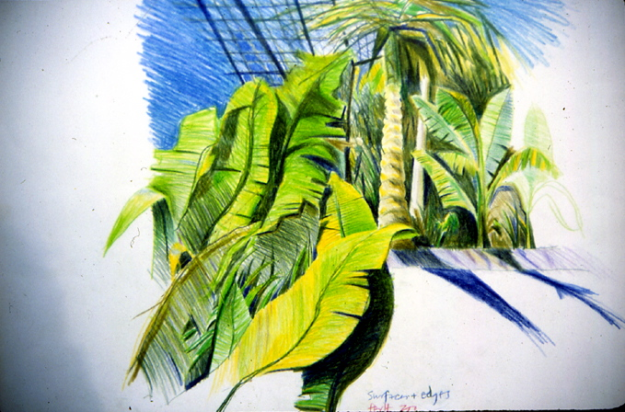
Figure 1 Surfaces and Edges: Perth Zoo
At first glance, Figure 1 appears to represent a scene from a fixed viewpoint familiar to most Western viewers’ experience. At the most detailed level of engagement indicated in the model (Table 1), each drawn mark at the extremities of the drawing (the only opportunity to scrutinise a mark isolated from other marks) whilst representing a variety of observations of sky, leaves and shadows, also serves a common compositional function: to guide the viewer’s eyes in a direction which leads to the same focus point. However, this focus point, a sharp-edged, deep blue V-shape, approximately at the centre of the drawing, turns out to represent a complexity of primary geometry. The contrast boundaries between the blue V and its surrounding colours in the drawing bring into sharp focus edges which, if viewed in the scene itself, would be separated by some distance, and therefore out of focus (our eyes can only focus on one plane at a time). Also, it may be noted that the scale and textural quality of the marks across the whole drawing have a similarity which denies the variety of scale of texture possessed by the actual vegetation to which these marks refer. Since the haptic values of the scene are thus suppressed, as are the distal values, (only the relative scale of shapes in the drawing, and the high-contrast boundaries between shapes provide cues for reading distance in depth), we may conclude that this drawing is designed to draw the viewer’s attention to the proximal values of the scene. This drawing reveals the maker’s interest in the patterns of natural form. At each level of engagement, the compositional selections from the systems of available choices function to foreground the interpersonal rather than the experiential. In such a viewer-centred drawing, the viewer is certainly psychologically positioned in relation to the scene, the sub-divisions of the drawing’s surface arranged so as to communicate balance, an organic balance emphasised by the salient contrast boundaries emanating both vertically and horizontally from the central V focus point, forming the axes from which the drawing grows. These two axes divide the rectangular format in the proportion known as the Golden Section, and the patterns of natural form mentioned earlier are implicit in the Golden Spiral which is the skeleton of the drawing.
The selections from within the yellow-green-blue colour range support the mood of calm balance. Only the rhythm of the undulating lines and contrast boundaries of the lower left quarter contrasting with the angular shapes of the palm crown provide the visual dynamism to prevent the stability of the drawing from becoming static. Here is a drawing that invites the viewer to share its maker’s interest in the proximal values of the scene, (at the expense of the haptic and distal values), and his concern with how compositional selections may instil in the viewer an awareness of how the abstract qualities of drawn marks may underpin any realistic representation.
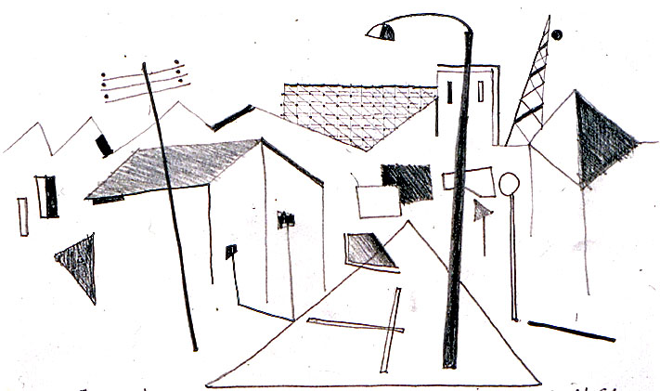
Figure 2 Fremantle Street 1
In Figure 2, the abstraction of a simple denotation system from the complex concrete form of the urban environment is effected through compositional choices. Scene primitives, those elements of the primary geometry of the environment such as edges and corners of material surfaces and the tonal and textural contrasts visible when such surfaces occlude one another in the visual world, are reduced, in the secondary geometry of the drawing, to a denotation system consisting only of line, dot, and limited tone. The only allusion to the three-dimensionality of the primary geometry of the street-scene is made through the use of the triangular shape with its base at the bottom of the picture plane and its apex mimicking the vanishing point of a one-point perspective projection. This serves to position the viewer (floating above the middle of the road!), as well as a means of drawing the viewer’s gaze into the centre of the composition.
The variety of thicknesses and densities of tone of the lines, and their positioning within the picture-plane, also provide some illusion of depth in the drawing. What is the viewer to make of such a minimalist representation of a three-dimensional solidity? Here are the bare bones of the visual field in which connections - false attachments - are made between lines that are clearly not representative of the actual spatial relationships within the scene. Scene primitives such as corners and textured surfaces which combine to form an integrated, material world, are disintegrated into picture-primitives attached to nothing, appearing to float in the picture-plane alongside the viewer
The viewer’s experience of the familiar public streetscape is rendered in an unfamiliar language of spatial description. Unfamiliar, except it consists of strangely-familiar linear profiles and recognisable shapes. The poetic device of closure is at work here, inviting the viewer to complete the puzzle by working out the false connections between lines on the drawing which actually represent material edges some distance apart in the actual scene.
Our familiar, solid world has been transformed. Our ontological bi-polar construct of solid/void is challenged. In these drawings, solidity and void co-exist on either side of every line. Just as the molecular scientist challenges our common-sense, empirically-based assumption about the solidity of material things by suggesting that the illusion of solidity is an accident of our perceptual systems of vision and touch, so these drawings may gently nudge our complacency of seeing.

Analysing History: Modernism re-viewed
The conventional description of the roots of Modernism in a visual arts context refers to the period in Europe spanning the socio-economic events known as the French Revolution, the Industrial Revolution and the Russian Revolution. This period saw the rise and consolidation of mass industrialisation and mass democratisation across Europe. The social upheavals symbolised by those labels also challenged many prevalent assumptions about the visual arts. Prior to this period, academic drawing (as practised in the Academies), emphasising the importance of geometry and proportion, had idealised the timeless constancy of the human figure. However, the shifts in consciousness brought about by the social and economic changes of the late-eighteenth and early-nineteenth centuries facilitated an alternative concept to Academic idealism: that of an individualised perceptual immediacy - the self-conscious eye – and the sensation of constant change. Artists, no longer patronised by a weakened aristocracy and Church, began to respond to their new-found freedom through ways of practice which have become known collectively as ‘Modernist’: Realism, Impressionism, Expressionism, relativism (Cubism, Futurism) and so on, are the terms that have come to be adopted to describe the phases of Modernism in a chronological order.
But another, more proactively analytical, rather than descriptive, way of construing those practices commonly known as Modernist is proposed here, one which is expedited by the use of the systemic-functional semiotic model illustrated in Table 1.
From the earliest period of Modernist painting and drawing, at a time when the concept of ‘realism’ was being re-examined, two fundamentally opposed strategies may be discerned beneath the labels of the ‘isms’. Firstly, one that serves to draw the viewer’s gaze through the picture’s surface and into its illusory space. Secondly, the strategy of drawing attention to the ‘picture-ness’, the materiality of the picture itself by exaggerating the artifice of Geometry and indications of the artist’s presence such as brush-strokes in the surface treatment of the medium and its support. In this second strategy, the viewer is forced to encounter the picture surface itself, so that any subsequent reading of the pictorial content (the depicted theme) is mediated by this negotiation of surface.

In terms of the model (Table 1), such manipulation of the Interpersonal function is realised through the systems of Gaze: the artist’s manipulation of the viewer’s specific eye-paths and focus points within the composition. The various ways that a viewer is invited either to gaze ‘through’ the picture-plane, or to focus upon the surface textures of the medium applied to the picture-plane are achieved through the artist’s selections from the compositional systems of Geometry at the level of engagement of the whole work, and through selections from the systems of Relative Size and Texture at the level of engagement of the drawn (or painted) marks.

Out of the two strategies identified, the first, negating the picture surface, employs choices from the systems of composition normally associated with the Academy: these are artificial perspective, aerial perspective, and the positioning of figures and manipulation of Gestalt relationships so that a sense of stable balance ensues. In this strategy, the materiality of the medium and its support is not emphasised. However, what transforms this Academic-based compositional strategy into an explicitly Modern work are the choices made from within the column labelled Experiential function. The traditional themes of the Academy works were those of history, religion and literature. In Modernist work these themes are rejected in favour of those of a more democratised, industrialised social context, with its implied leisure time and public social activities. William Powell Frith’s 1862 The Railway Station (Royal Holloway College, University of London, available at: http://picturegallery.rhul.ac.uk/searchableCatalogue.htm?pid=38) illustrates an example of the transition between the Academy and the Modern, as he utilises the Academic compositional devices of artificial perspective and aerial perspective to emphasise the distal and the proximal values in the scene, and treats the picture surface in such a way as to negate its haptic qualities thus reinforcing the illusion of transparency.

The Academic devices of symmetry and visual balance are evident in the positioning of the three most salient lighting globes, each directly above, and leading to the viewer’s gaze down to, three cameos depicting the modern world of the time: on the left, a family with their luggage push towards the carriage; in the centre, a scene of farewells forming a stable triangular shape beneath the lighting globe, itself the apex of a triangular pattern of lighting globes, and on the right, a thoroughly urban Modernist event, the arrest of a man (a suspected pick-pocket?) by top-hatted ‘peelers’.
The second strategy – that of drawing attention to the surface qualities of the picture - also specifies Modernity by addressing themes of social democratisation and mass industrialisation, but unlike Frith, Claude-Oscar Monet’s 1877 Gare St. Lazare (National Gallery, London, available at: http://nationalgallery.org.uk/paintings/claude-oscar-monet-the-gare-st-lazare) provides an illustration of this strategy of surface modulation:
Here the viewer is confronted with the physical materiality of the picture-plane. This is achieved through the use of compositional devices which emphasise the texture of the medium and its support, and which subvert the system of artificial perspective and the conventions of aerial perspective. In this way, the medium becomes the message, or at least the medium powerfully modulates the viewer’s response to the depicted subject-matter. The haptic qualities of the picture surface are emphasised, and the sub-dividing of the overall composition produces a dynamic, rather than static, balance. Passages of paint depicting the steam from the engine on the left of the picture are distinctly glossier than their surroundings, a contrast of texture which serves to animate the overall surface as the viewer shifts position, thus drawing attention to these surface qualities. Brush marks are clearly evident, with little change in their size across the whole canvas. Where brush marks form contrast boundaries (a classic cue for spatial depth), for example between the girder of the triangular roof and the steam-filled atmosphere, they are left rough and ragged, at various levels of impasto which draw attention away from the possibilities of depth illusions and instead emphasise the butting together of pigments upon the surface. One mark of red paint acts as a boundary between the roof structure and the arch depicted on the extreme right of the picture; this, too, draws attention to the painterly qualities of the surface. Figures in the foreground are represented by loosely-applied blobs and dabs of pigment, as is the central lamp-post. Blobs and dabs standing proud of the canvas surface, draw attention to the materiality of the pigment itself.
From Depiction to Abstraction?
Such close analysis, facilitated by a systemic-functional semiotics, affords the opportunity to explain one of the most dramatic shifts ever to occur in European art history; the shift from representationalism towards abstraction. It could be argued that the emphasis upon material qualities in this second strategy, in Richard Brettell’s (1999:15) term “Mediated Realism”, led, ultimately, to abstraction in the early twentieth century, since the strategy allowed artists to recognise for the first time that the product of their labours, its very materiality, could be the object of contemplation, rather than that which may be represented by such materials.
References
BRETTELL, R. Modern Art 1851-1929. Capitalism and Representation, Oxford, Oxford University Press. 1999.
FIRTH, J. Papers in Linguistics 1934-1951. Oxford: Oxford University Press. 1957.
HALLIDAY, M. A. K. Explorations in the Functions of Language, London, Edward Arnold. 1973.
HALLIDAY, M. A. K. Language as Social Semiotic: the Social Interpretation of Language and Meaning, London, Edward Arnold. 1978.
HALLIDAY, M.A.K. An Introduction to Functional Grammar. London: Edward Arnold, 1985.
HUGHES, A. U. & RILEY, H. The Multi-modal Matrix: Common Semiotic Principles in the Modes of Narrative Film. Proceedings of the10th World Congress of the International Association for Semiotic Studies (IASS). University of La Coruna: IASS. 2009.
KRESS, G. Multimodality. A Social Semiotic Approach to Contemporary Communication, London, Routledge. 2010.
KRESS, G. & VAN LEEUWEN, T. Reading Images. The Grammar of Visual Design, London, Routledge. 1996. 2nd ed. 2006.
MALINOWSKI, B. The Problem of Meaning in Primitive Languages. In OGDEN, C.K. and RICHARDS, I.A. The Meaning of Meaning. London: Kegan Paul. 1923.
O'DONOHOE, E. and RILEY, H. A Systemic-Functional Semiotic Model for the Analysis of Image/Text Works. In Communication: Understanding/Misunderstanding. Proceedings of the 9th World Congress of the International Association of Semiotic Studies (IASS). Vol. 2, edited by E. Tarasti, 1209-17. Helsinki/Imatra: IASS, 2009.
O'TOOLE, M. The Language of Displayed Art. London, Routledge. 1994, 2nd ed. 2011.
O’TOOLE, M. A Systemic-Functional Semiotics of Art. Semiotica, 82 (3/4), (1990).185-210.
RILEY, H. The Intelligence of Seeing. An Inquiry into the Relationships between Perception Theory, Communication Theory and the Practice and Teaching of Drawing. PhD thesis, University of Wales. 2001.
RILEY, H. & O'DONOHOE, E. A Systemic-Functional Semiotic Model for Visual Communication. Proceedings of the 10th World Congress of Semiotics. La Coruna: IASS. 2009.
ROBERTS, A. and RILEY, H. Drawing, Gesture and Semiotics: An Exploration of the Semiotic Potential of Gesture Drawing. In CORTE-REAL, E. (ed.) Senses and Sensibility in the Right Place. Proceedings of the 6th UNIDCOM/IADE International Conference. Lisbon: Institute of Visual Arts, Design and Marketing (IADE). 2011.

