Title: The Social Semiotic Potential of Gestural Drawing
Authors: Amanda Roberts, Howard Riley
Word Length: 3923
Biographical Notes:
Howard Riley studied at Hammersmith College of Art, Coventry College of Art, and the Royal College of Art. He holds a doctorate of the University of Wales in the practice and pedagogy of drawing. He is Professor of Visual Communication and Head of the School of Research and Postgraduate Studies, Dynevor Centre for Arts, Swansea Metropolitan University. He has published in the areas of visual semiotics, the pedagogy of drawing, and multimodality. His drawings have been exhibited in Australia, Malaysia and Finland as well as the UK.
Amanda Roberts is a PhD student at Dynevor Centre for Arts, Swansea Metropolitan University. She studied at Swansea University and the Faculty of Art & Design, Swansea Institute of Higher Education. Her practice focusses upon representations of the figure, and is concerned with life drawing and conventions related to the female nude. She is currently studying for a doctorate in the theory and practice of drawing at the Dynevor Centre for Arts, Swansea Metropolitan University. Her drawings and paintings have been exhibited widely in the UK.
Abstract:
This article explores the relationship between semiotic understanding and gestural drawing practice. Gesture is discussed as an integral drawing strategy in the production of a body of practical research titled Extended Drawings. Recent debate (Schneckloth 2008) about whether gestural and embodied practice falls outside the realm of semiotic analysis is addressed, and a selection of the Extended Drawings series is analysed within a semiotic framework. Specifically, a systemic-functional semiotic model is introduced and explained. Such a model is shown to facilitate the negotiation of a wider range of meanings than otherwise available, particularly revealing underlying assumptions of the model/artist/viewer social relationships. It is concluded that no drawing practice is beyond the realm of the semiotic, and that semiotic analysis is applicable across the whole domain of drawing, including the gestural, as a means of generating meaning.
Introduction
The stimulus for this article came from a close reading of Sara Schneckloth’s (2008) Marking Time, Figuring Space: Gesture and the Embodied Movement, published in the Journal of Visual Culture . In her abstract, she observes that the drawn gesture affords a ‘…potential to convey meaning beyond the semiotic…’ Such an intriguing – and, to a semiotician, challenging - statement naturally attracted the attention of the two present authors, one a social semiotician involved in drawing practice and teaching, the other a PhD student whose practice is based upon life drawing, exploring the concept of extended drawing. This term refers to a body of practical research that engages with a specific method of multi -perspective drawing. The method was developed as a means of retaining observational figurative representation and the contained form of the figure, without the rigidity of one point perspective.
An explanation of the working method used to produce Tonya: Elevated Perspective (Figure 1) illustrates the method employed in the extended drawing technique. Extended drawings begin with a selected focal area from which the drawing expands. In this example the model lay on a mattress on the floor, and the first sheet of paper placed on the floor next to her. The initial focus of the drawing was the relationship between the averted profile of the model’s face, her arm and her shoulder (Figure 2).
Figure 1 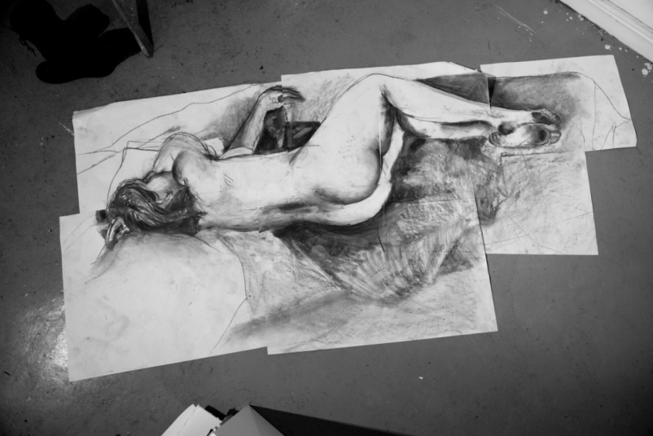 Figure 2 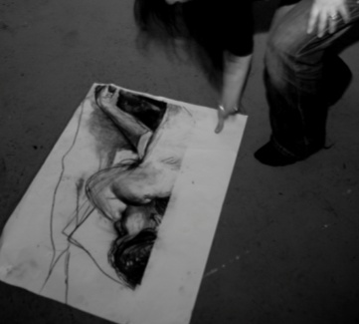
Additional sheets of paper were added to extend the drawing as it developed, each new sheet secured with masking tape. The scale of the work necessitates the artist shifting viewpoints as the drawing enlarges. Viewpoints vary and the distance between artist and model alters. The model’s profile was drawn sitting on the floor, her torso represented from above. Each part of the figure is drawn as seen from a unique viewing position. Although a one -point perspective measurement system is neither appropriate, nor practically applicable for the production of an extended drawing, plumb lines and internal proportional measurements often are appropriate. A close observation and recording of negative shapes (those shapes in the field of view which constitute background, rather than parts of the figure), and convergent lines (lines that incline toward each other, or toward a common point of meeting) was integral to maintaining a sense of ‘accuracy’ associated with observational drawing. Keeping the drawing open -ended and flexible allows elements to be adjusted to match the compositional whole, rather than to comply with mathematically -accurate measurement. The following sequential reconstruction of Tonya; Elevated Perspective (Figure 3) maps the process of producing an extended drawing. Reconstructing the image for the studio or gallery wall involves reassembling fragments of the body in the same order they were drawn.

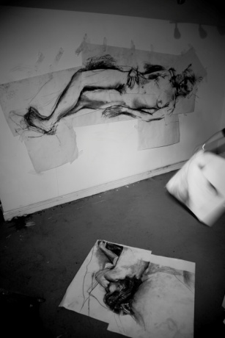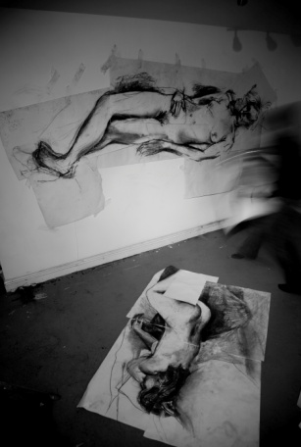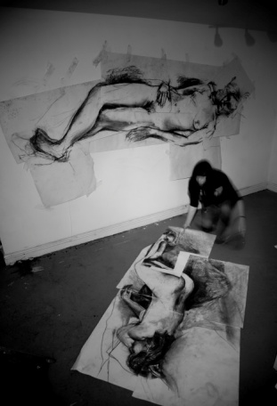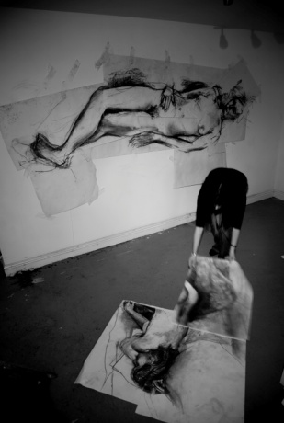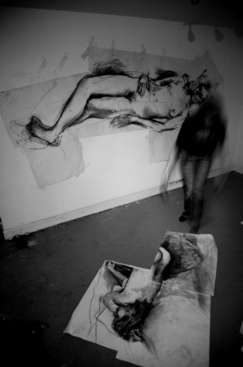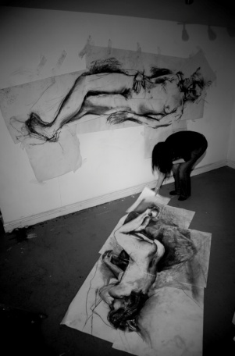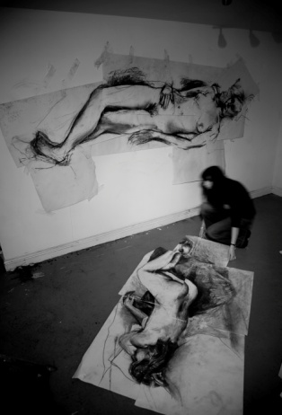
Figure 3
This particular drawing (Tonya: Elevated Perspective) is displayed on the floor, the emphasis placed on the downward viewing position. In contrast, the extended drawing on the background wall in Figure 3 places the figure and the viewer at eye level, echoing the viewpoints of the artist.
Each subsequent reconstructed display of the drawing alters it slightly, since despite the charcoal marks having been sprayed with fixative, areas of charcoal still smudge when handled, and where the drawn marks on separate sheets are not in perfect alignment, they are re-drawn and areas of tone darkened. Older layers of masking tape from previous assemblies leave their marks and so the represented body subtly changes, and evolves through its reconstructions.
Gesture and Embodiment
Although the terms gesture and embodiment are closely related, with interchangeable characteristics, a consideration of the complexity of their implications and associations is appropriate in relation to the practice of extended drawing. Gesture, deriving from the Latin gestūra, a noun of action applied to drawing practice, relates to works that incorporate or prioritize movements of the body. (Noland and Ness 2008) Gestural drawing is commonly associated with quick, non-measured mark making, for example, quick sketches of short poses in the life drawing room. Action painting, exemplified by Jackson Pollock and the current paintings of James Nares (Kuspit, 2006) prioritizes the gestural mark above figurative or compositional restraint. The scale of the extended drawings and the prevalence of large sweeping marks necessitate movement by the artist and results in a very physical drawing process, the traces of which are evidenced in the marks produced. (The rich semiotic implications of these gestural marks are elaborated in the analysis which follows the section introducing the systemic-functional model below).
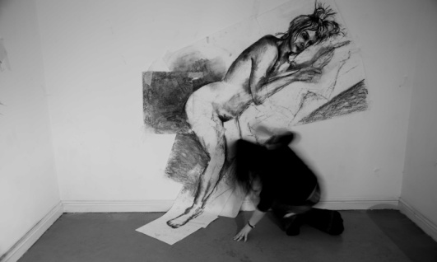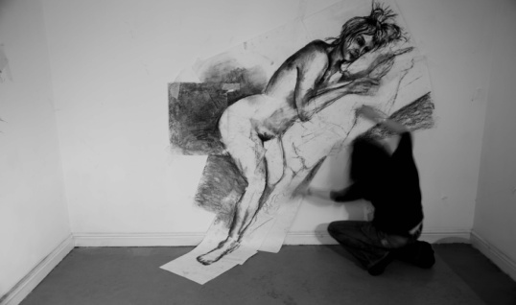
Figure 4
Carrie Noland identifies the contradiction between the association of gesture as an expression of spontaneity and the understanding of gesture as a definition of intentional or culturally formed posturing of the body. (Noland and Ness 2008) It is possible that the potential discordance of self-conscious physical posturing and the intuitive gestural mark find common ground in representations of the figure which are able to reference gesture in both the marks made by the artist and the compositional positioning of the represented figure.
Concepts of embodiment relate most closely to the intuitive gestural mark: ‘Gestured marks are an embodied language…’ (Schneckloth 2008:279) Embodied mark -making in relation to life drawing is integral both to the body that has produced it and the body it describes. This proximity is such that the relationship between the body and the drawing - or even the mark - becomes indivisible. There is an association of embodied drawing as being intuitive and unmediated, grounded in the physicality and experience of the subject matter and the media employed.
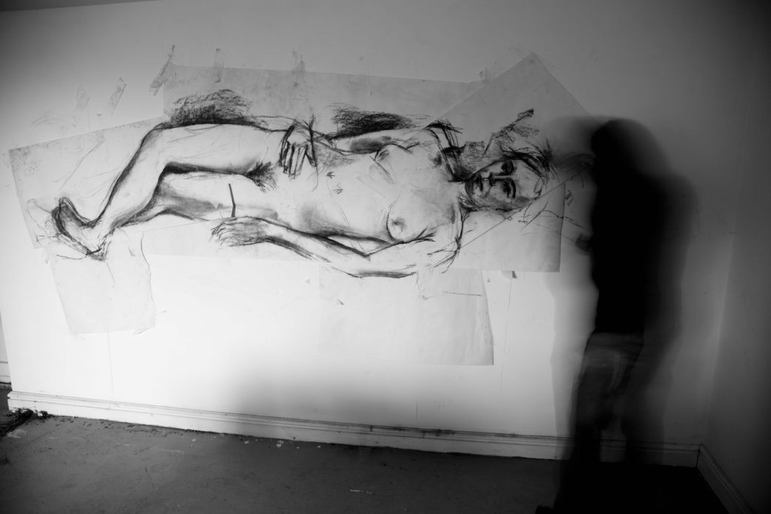
Figure 5
The Oxford English Dictionary defines the term embodied : ‘To impart a material, corporeal, or sensual character …To cause to become part of a body; to unite into one body…Of soul or spirit: Having a body, invested with a body…To put into a body; to invest or clothe (a spirit) with a body.’
Understandings of embodiment as entirely instinctive and unconscious shamanistic transversals of the actual body into the represented image are incompatible with one -point perspective and rigid methods of measurement. It is not an intention of extended drawings to avoid measured or considered mark-making, neither is it the intention for the drawing to embody the experiences of the artist or the model in their entirety. In extended drawings, more mediated responses are overlaid and combined with marks that represent an immediate and intuitive reaction to the model and directly correspond to the physical gesturing of the artist.
Noland comments that it is ‘…rare for a semiotician to consider the ways in which the experience of producing a sign….contributes to the sign’s contour, dynamics, duration or communicative force.’ (Noland and Ness 2008: xiii)
Rare maybe, however, it is clear that the extended drawings discussed here translate experiential proximities between drawer, life-model and viewer both instinctively and geometrically into mark making and, as this paper demonstrates, there is tangible semiotic potential in the marks that are made.

The Social Semiotics of Drawing
From a materialist point of view, drawings are produced through the selection and combination of particular surfaces, drawing tools, and the marks resulting from their interaction. But semiotically speaking both artists and viewers of drawings take up positions, adopt attitudes, points of view which are influenced by their positions within their sets of social relations. Nowhere is this more clearly demonstrated than in the drawings under discussion in this article.
Such an ideological positioning involves a definite way of using signs, and a structured sensibility (an aesthetic) both grounded in a particular system of social relations. How the artist selects and combines the compositional elements of the drawing, and how the viewer relates to that drawing are both functions of the social contexts in which the work is (re)produced.
But to simply say that drawings reflect social structure, (or in this case, the social relations between artist, model and viewer) is too passive: drawing not only expresses the social context but is also part of a more complex dialectic in which drawings actively symbolise the social system, thus producing as well as being produced by it.
Variation in ways of drawing is the symbolic expression of variation in social relationships. Drawing systems are produced within society, and help to produce social form in their turn. This dialectical relationship is what the socio-linguist Michael Halliday (1978:183) discusses in the phrase social semiotic.

Varieties of drawing
Of the two kinds of variation in language identified by Halliday (et al.1964), dialect expresses the diversity of social structure, and register expresses the diversity of social process. Whilst the meaning of dialect may be commonly understood, register may require further discussion. It refers to the fact that language usage varies according to the situation in which it is used.
In terms of drawing, register would refer to the variation in selecting and combining visual elements according to the purpose for which the drawing was produced, which, we suggest, would certainly encompass ‘…the drawn gesture…’ that Schneckloth (2008:287) argues is beyond the semiotic.
From this social semiotic perspective, any social context may be understood as a temporary construct, mapped in terms of three variables which Halliday (1978:33) calls Field, Tenor, and Mode.
Field of social process – what is going on at the time of production of the drawing.
Tenor of social relationships – the type of drawing we produce varies according to the level of formality, of technicality, of need for clarity of communication, etc. It is the role relationships – the drawer, the subject matter, the viewer and their interrelationships – that affect the variations.
Mode of symbolic interaction – in the sense that how we draw, and with which particular medium, varies with our attitude; from the clinically objective through the poetically gestural to an absent-minded doodling,

The Functions and Systems of Drawing
Any code of communication (language, dress, drawing …) has three main functions: to represent some aspect of our experiences of the world; to both express our attitude, mood regarding our experience, and to position the receiver in terms of mood and attitude towards that which is being represented; and thirdly to structure these two into a coherent, perceptible form. These functions may be termed the representational, the interpersonal, and the compositional.
The parameters of social context, field, tenor, and mode are systematically related to the functions of the semiotic model. In fact, those meanings that constitute our understanding of any particular social situation are made visible through the selection and combination of elements within the semiotic model.
Parameter of social context | Function of drawing through which a social situation is realised
Field (what is happening) | Representational function
Tenor (who is taking part) | Interpersonal function
Mode (what part the semiotic code plays) | Compositional function

Figure 6 The Parameters of Social Context
Such a model which theorises how the functions of drawing operate within a social context relates specific choices to specific social contexts. We are thus able to imbue the relationship between code and social structure with dialectic resonances.
The chart shown here, Figure 7, is an attempt to map these functional relationships for the whole domain of drawing, and is an adaptation of Michael O'Toole's (2011) format for analysing paintings. It should be noted that each term within each box of the model – for example, Theme in the first box - represents the whole range of available selections embraced by the term itself: every theme available to the artist (or indeed for the viewer’s interpretation!) Each range of available choices implied by all those terms is what Halliday meant by System: a Hallidayian system represents a range of available choices. Hence the term Systemic-Functional semiotics!

. Function  Function  Level of  Engagement | REPRESENTATIONAL (what is depicted) | INTERPERSONAL  (how the viewer is positioned in terms of mood and attitude) | COMPOSITIONAL  (how is it depicted)
Drawing as Displayed | Theme  Narrative  Genre  Representational/abstract  Interplay of episodes/passages | Attitude, modality  Rhythm/focal points  Intimate/monumental  Public/private  Dynamic/static | Overall format and size  Gestalt relations: horizontals, verticals, diagonals  Framing/mounting  Range of colour/B&W  Systems of geometry:  persp, ortho, axo, etc.
Episodes of the Drawing | Actions, events central to narrative supporting narrative | Orientation of viewer  Perspective/non perspective  Gaze/eyework  Modality: happy/gloomy, calm/excited etc. Calm/excited etc. | Relative position in drawing  Interplay of figures/passages  Contrast of tone/texture
Combinations of marks  (sub-assemblies) | Direction  Transparency/opacity  Atmosphere  Time of day  Surfaces/edges | Distance  Force  Heavy/lightweight  Flatness/illusions of depth | Relative positions of marks  Relative sizes of marks  Division of picture-plane: ratios, angles  Overlap of shapes/tones
Individual Marks | Effects of light on surfaces and media (air, water) in the environment | Hard/soft Stylisation  Matt/gloss  Wet/dry  Indices of maker’s movements | Position within picture plane  Texture of surface  Medium combination  Size relative to picture-plane

Figure 7 The Functions and Systems of Drawing
A Semiotic Analysis of Gestural Drawing
A useful entry point to the semiotic analysis of the series of life drawings presented in this article would be the mapping of the specific parameters of the particular set of social relations existing at their execution onto the three functions identified in Figures 6 and 7:
Field: A private studio drawing session.
Tenor: Female model and female artist interact at close quarters, with the artist directing the model’s pose, and shifting viewing/drawing positions at regular intervals.
Mode: The interaction is realised visually through a series of charcoal drawings taped together, unframed and displayed in a variety of dispositions; wall-mounted, floor mounted.
It is worth emphasising here that each of these parameters is loaded with semiotic potential and represents a series of selective choices on the part of the artist. A private studio space is a very different working environment to a public life drawing room, a consideration of the environment in which drawings have been produced can enhance and expand implicated meanings. The representation of a life-model - and the particular choice of a female model - generates socially- and culturally-specific associations . That semiotics offers an appropriate strategy for examining the implications of the choice of life- model is illustrated by Wendy Steiner (2010) in The Real Real Thing. The Model in the Mirror of Art where she uses a semiotic adaptation of Roman Jakobson’s (1958) theory identifying six functions of communication in order to examine the relationships between the life-model, the drawing, the drawer and the viewer. Jakobson’s seminal work also underpins Halliday’s, O’Toole’s and our own semiotic approach, demonstrated below:
Once the specifics of the three parameters defining the social context are established, the drawings may be analysed in terms of the three -function model (Figure 7), at a variety of levels of engagement:
At the level of engagement The Drawing as Displayed, the compositional choices of close-up viewing positions from a variety of viewpoints afford the viewer opportunities to compare the perception of pictures with the perception of our four-dimensional world: we view the world from a moving path of observation. This reality of the perceptual process is implicit in these drawings, rather than obscured in the conventions of a single-point perspective projection system of geometry.
In terms of the interpersonal function, the viewer is positioned as an active participant, invited to adjust their viewing position, in contrast to the vulnerability of the model’s passive, static pose. The permutations of potential meanings to do with gender/power relations, both between artist and model and between the drawing and its viewers, may well stimulate those viewers to reconsider their individual preconceptions about, and stances towards, the possible permutations of those relations.
Also at the level of engagement The Drawing as Displayed, the compositional decision not to frame, from the range of choices (what Halliday termed a system) labelled in the chart, Figure 7, as the system of Framing/Mounting, carries significant semiotic potential; the resultant ‘zig-zag’ edges of the sheets imbue the drawings with a dynamism at odds with the passivity of the pose represented, which challenges viewers to make sense of – to resolve – the tensions thus set up. Here is the source of the pleasure we experience when looking at drawings: the resolution of the tensions – visual, emotional, psychological - implicit in all good art. (Kreitler and Kreitler 1972)
At the level of engagement labelled Episodes of the Drawing, the junctions between the sheets of paper secured by masking tape create edges which form a linear network, one which invites the viewer to alternate their attention between the mass of the body’s forms represented by the shapes of tonally-graded charcoal gestural marks and the tensile visual structural network which holds those forms together – akin to the delicate sensitivities that bind model and artist, but which also hold the viewer in this rhythmic relationship facetted through the multiple viewpoints – a prism-house of available semiotic meaning potential (with apologies to Frederic Jameson’s rather negative phrase ‘prison-house’ referring to the limitations of language). Our comfort zone of perceptual assumptions, together with that of gender relations, are both disturbed in these drawings, provided, of course, that the viewer is willing to engage with these issues – a function Roman Jakobson (1958 ) called the conative in his seminal paper delivered at the Conference on Style in Language held at Indiana University in April 1958. (1) The reconstruction of the drawings echoes the bodily involvement of the artist in the composition and assembly of the represented figure. It introduces a narrative additional to and supportive of the exhibited work.
The analysis continues at the next level of engagement Combinations of Marks, addressing the semiotic potential realised through the choice of charcoal, an organic medium capable of being held so that the stick’s whole length makes contact with the paper, facilitating marks of varying widths and tonal densities, or so that the point of the stick touches the paper like a pencil. These performative choices enable the production of a combination of marks representing the wide variety of graduated tones visible on the surfaces of the model and her surroundings as well as delineating the edges and occlusions between those surfaces. (Figures 8 and 9). The gestural nature of these marks constituting the drawing as a whole, with their swoops of tonal gradation and the blurriness of their edges contrasting with the dynamism of line quality varying from light to dark, thick to thin, augment the perceived sensation of movements for the viewer: the viewer willing to engage at this level experiences the sensations of the drawer’s movements around the static life-model. Furthermore, the juxtapositions of embodied gestural marks with the more measured mark making discernible at this level of engagement allow for insights to be perceived by the attentive viewer into the range of levels of concentration demanded of the drawer: the viewer might experience the process of production even whilst in the process of consumption!
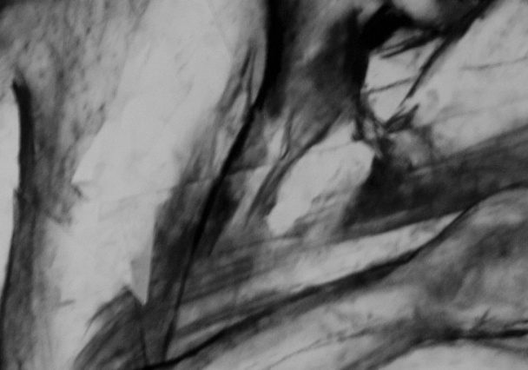 Figures 8 and 9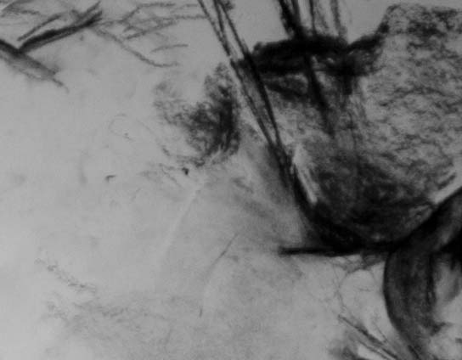
We shall move on to the most detailed level of engagement, labelled in Figure 7 as Individual Marks. Each individual mark carries semiotic potential, each gestural mark may be understood as a seme, a basic unit of meaning: for example, in Figures 8 and 9, each mark is an indication of the artist’s movement – indeed, each mark is the result of the artist’s bodily position, as well as being a clear indexical sign caused by the pressure of the hand, and the speed of the hand’s movement. For the viewer willing to engage in such delicacy of detail there is the reward of recognising the rich variety of potential social meanings available throughout the realm of drawing activities, including - and in the context of Schneckloth’s argument that stimulated this response - the particular case of the individual gestural marks.
Conclusion
This article has demonstrated the rich potential of gestural drawing as a means of exploring social relations at the heart of all representational art: the relations between subject-matter, (in this case the life-model), artist and viewer. A model of systemic-functional semiotics such as the one featured here might well inform the future practice of those interested in extending the potential meanings of representational drawing in general, and those of gestural drawing in particular. The authors would like to acknowledge here the stimulus of Schneckloth’s article driving our response, offered in a spirit of collaborative inquiry. All constructive criticism and comment is welcome.
Endnotes
1. Jakobson’s contribution is recognised as seminal today, but not at the time, according to Gordon M. Messing’s (1961), review of the conference proceedings. Messing seems to have failed to recognise the significance of Jakobson’s paper: ‘The closing statement by Roman Jakobson (350-77), on the other hand, while filled with interesting incidental matter, bears too little relevance to the other papers and discussions.’ A lesson for all hasty reviewers?

References
HALLIDAY, M.A.K., McINTOSH, A. & STREVENS, P. 1964 The Linguistic Sciences and Language Teaching. London: Longman.
HALLIDAY, M.A.K. 1978 Language as Social Semiotic London: Edward Arnold.
JAKOBSON, R. 1958 Closing Statement at the Conference on Style in Language: Linguistics and Poetics. In SEBEOK, T. A. (ed.) 1960. Style in Language. Cambridge MASS/London: MIT Press/John Wiley.
KREITLER, H. and KREITLER, S. 1972 Psychology of the Arts. Durham, NC: Duke U.P.
KUSPIT,D. 2006 James Nares's Action Paintings and Chronophotographs. Art New England, 27(3), 10.
MESSING, G.M. 1961 Review of SEBEOK, T.A. (ed.) 1960 Style in Language. Cambridge MASS/London: MIT Press/John Wiley. In Language, Vol. 37, No. 2 (April /June1961) 256-266
NOLAND, C. & NESS, S.A. (eds.) 2008 Migrations of Gesture. Bristol/Minnesota: Univ. of Minnesota Press.
O’TOOLE, M. 2011 The Language of Displayed Art. 2nd ed. London: Routledge.
SCHNECKLOTH, S. 2008 Marking Time, Figuring Space: Gesture and the Embodied Moment. Journal of Visual Culture, 7(3), 277-292.
STEINER, W. 2010 The Real Real Thing.The Model in the Mirror of Art. Chicago:The University of Chicago Press.

