innovative insole to reduce focal plantar pressure

Yajie Zhang (1), David John Barton (2), Heather Smart (2), Jane EA Lewis (3)

1. Assistive Technologies Innovation Centre, University of Wales Trinity Saint David, UK; 2. Kaydiar Ltd, UK; 3. Cardiff School of Sport & Health Sciences, Cardiff Metropolitan University, UK

Introduction
Focal excessive pressure is a risk factor in forming hyperkeratosis, and inducing lesions of the foot, such as corns and calluses [1], which are common foot problems and can cause pain and impact quality of life [2]. A podiatrist may provide treatment that includes specially made soft pads or insoles to take pressure off the painful area. ZeroSole insoles were designed with a modular cell structure allowing cells to be removed to create a cavity to offload the customized areas, before the hard corns or calluses get to the wound stage. Is such innovation effective to offload plantar pressure for users who have not developed with any lesions?

Methods
Fifteen healthy participants performed the tests. Ultra-thin, in-shoe F-Scan sensors were put between the foot and the ZeroSole to capture the plantar pressure distribution and temporal gait parameters. Participants walked on a 9-m walkway under 4 ordered conditions – C1: No ZeroSole, C2: ZeroSole No Cavity, C3: ZeroSole One Cavity, C4: ZeroSole Two Cavities. The cavity was created around the second metatarsal-phalangeal joint (MPTJ) area by removing three modular cells from the insole in a triangle shape, which was covered by a target zone of the F-Scan pressure measurement system. After the walking test, user experience data were collected about insole fitting, comfort rating and balance feeling. Gait parameters were examined in the middle gait cycles, with mean and peak pressure of the target zone, plantar forces and pressure heatmaps.

Results
No significant difference existed between conditions for all gait parameters (stance time, swing time, gait cycle and Robison symmetry index [3]). The mean pressure of the target zone showed a decreasing trend from C1 to C4, similar as the peak pressure (example pressure distribution at averaged peak stance shown in Figure 1), as well as force changes in the metartarsal, heel and the whole foot regions. Compared to normal footwear walking (C1), using the ZeroSole with one cavity (C3) decreased the mean pressure about 28% in the target zone for the same side of the foot and 23% for the other side, and using insoles with both cavities (C4) decreased by 29% and 27%, respectively. User experience data showed users’ satisfaction in comfort, no imbalance feeling and provided insights for future design development.

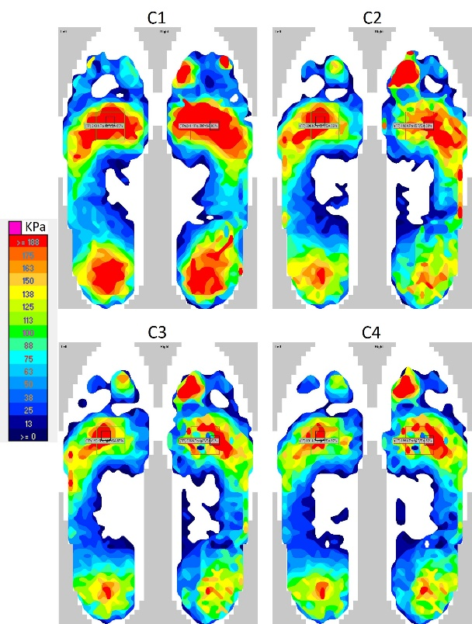
Figure 1: Example of a participant’s foot pressure distribution under all conditions. A cavity around the 2nd MPTJ was created on the right insole for C3.

Discussion
Wearing the ZeroSole insoles could effectively take pressure off the target area, redistribute the pressure under the feet without affecting gait. The insoles offered cushioning effects, evidenced by reduced plantar forces. In a similar study, using another two types of pixelated insoles had the percentage reduction over 40% when pixels were removed [4], which might be due to extra pad added under the MPTJ for elevated focal pressure. Both objective and subjective responses suggest the ZeroSole is promising to benefit people as an over-the-counter product. More clinical research would further test their effects in a long term.

References
- Singh et al, BMJ, 312:1403-1406, 1996.
- Farndon et al, J Foot Ankle Res, 8:1-7, 2015.
- Robison et al, J Manip Physiol Ther, 10:172-176, 1987.
- Penny et al, J Wound Care, 29:S18-S26, 2020.

Acknowledgements
This work was facilitated through the Accelerate Wales programme, led by Life Sciences Hub Wales, co-funded by the European Regional Development Fund (ERDF) through Welsh Government.

